**Assignment 4 Courier Management System DIVYA SREE MURALI**

**Overview of the Assignment:**

**The assignment is about creating a courier management system where different users can place orders, couriers and employees of specified courier company handles the couriers with given courier services specified. The Sql part deals with creating various foreign key relations and altering tables with data whenever required. All the queries of sql is implemented successfully and outputs corresponding to each query is attached starting from task1. For reference, er diagram is also provided. The coding exercises are bits of code implementation and the programs along with corresponding outputs are provided. From task5 OOPS implementation, I have little bit modified the folder structure and it is specified below, all the functionalities and user interfaces are created.**

**Task 1(28-09-2024)**

**Modification(11-10-2024)**

**Since I have added orders and parcels tables and added few foreign key relationships, I have changed the Database Schema accordingly**

**Data Base Schema based on the information listed in Courier management system**

**1.Understanding Entities and Attributes**

* User: Represents individuals who interact with the courier service.
* Courier: Represents individual shipments or packages.
* CourierServices: Represents different types of courier services offered.
* Employee: Represents individuals working for the courier service.
* Location: Represents different geographical locations.
* Payment: Represents financial transactions related to courier services.
* Orders: Represents orders placed by each customer
* Parcels: Represents the parcel entities for orders

Unique Constraints: The Email and TrackingNumber columns in the User and Courier tables, respectively, are defined as unique to prevent duplicate entries.

|  |  |  |
| --- | --- | --- |
| Component | Description | Used |
| Tables | Logical structure to store data in rows and columns. | Users, Couriers, CourierServices, Employees, Locations, Payments, Orders, Parcels |
| Data Types | Attributes or fields that define the data stored in each row of a table. | INT, VARCHAR(255), DECIMAL(10, 2), DATE,TEXT |
| Primary Key | Uniquely identifies each record in a table. | UserID in Users, CourierID in Couriers, ServiceID in CourierServices, EmployeeID in Employees, LocationID in Locations, PaymentID in Payments,  Orderid in orders, parcelid in parcels |
| Foreign Key | Establishes a relationship between two tables. It references the primary key of another table | CourierID in Payments referencing Couriers, LocationID in Payments referencing Locations  serviceid in couriers referencing courierservices  userid in orders referencing users  courierid in orders referencing couriers  parcelid in parcels referencing orders  empid in orders referencing employees |
| Constraints | Rules enforced on columns to maintain data integrity. | NOT NULL, UNIQUE-email and tracking number, PRIMARY KEY, FOREIGN KEY |
| Relationships | Define how tables relate to each other, usually through foreign keys. | Users to Couriers via UserID, Couriers to Payments via CourierID etc |

**2.Creating database andTables**

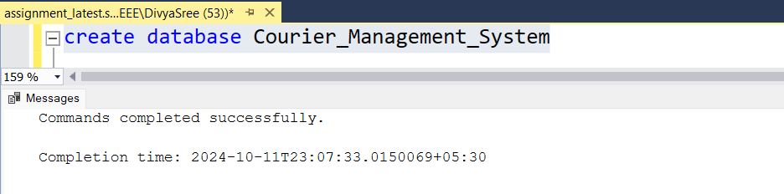

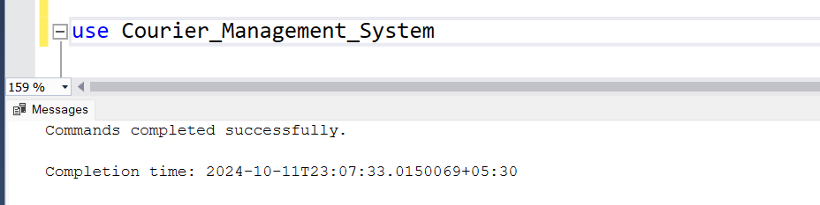

**2.1.User Table**

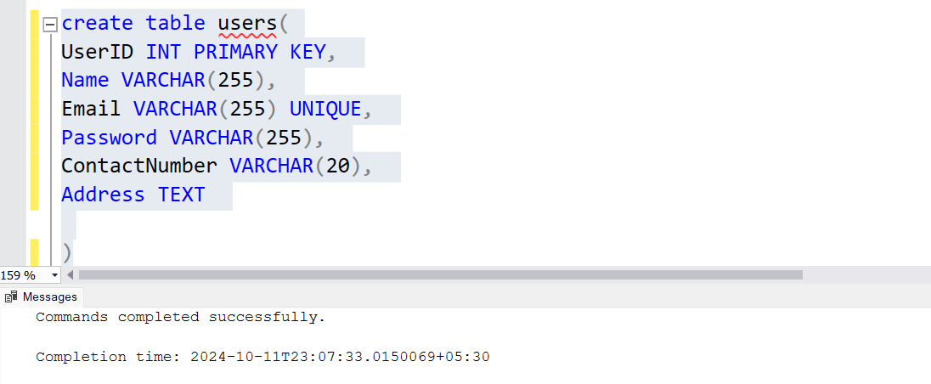

**2.2. Courier Table**

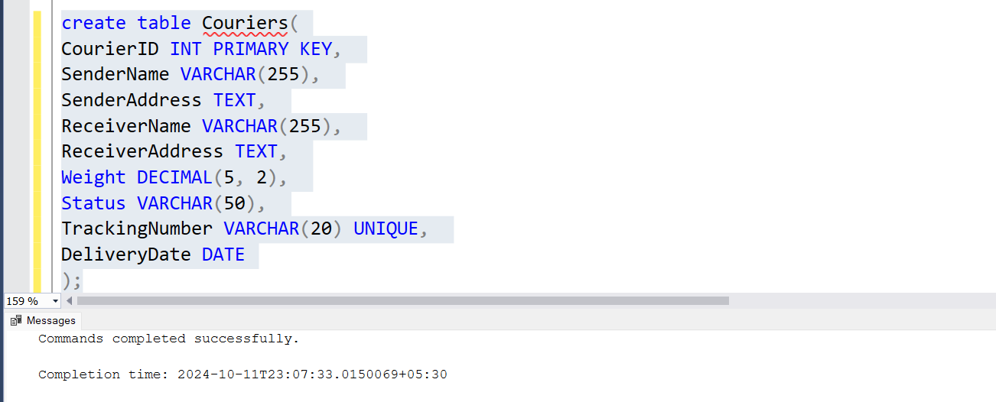

**2.3.CourierServices Table and Creating Foreign key relationship between couriers and courierservices Table**

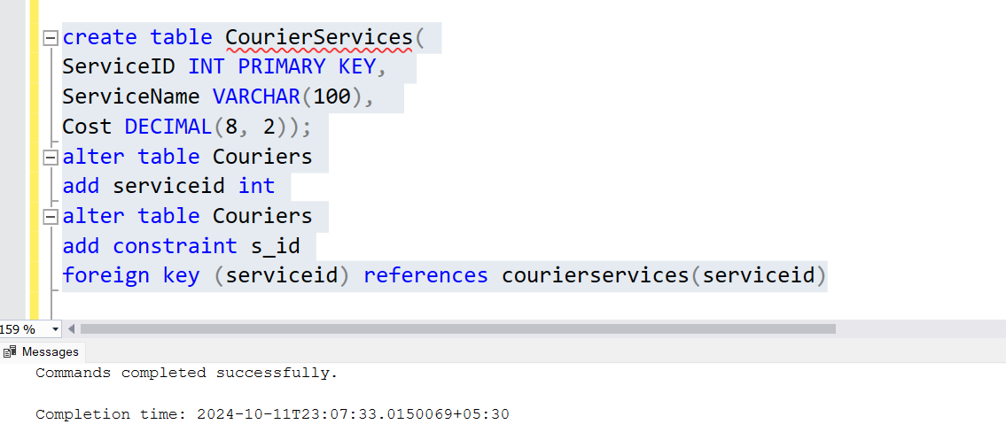

**2.4. EmployeeTable and Location Table**

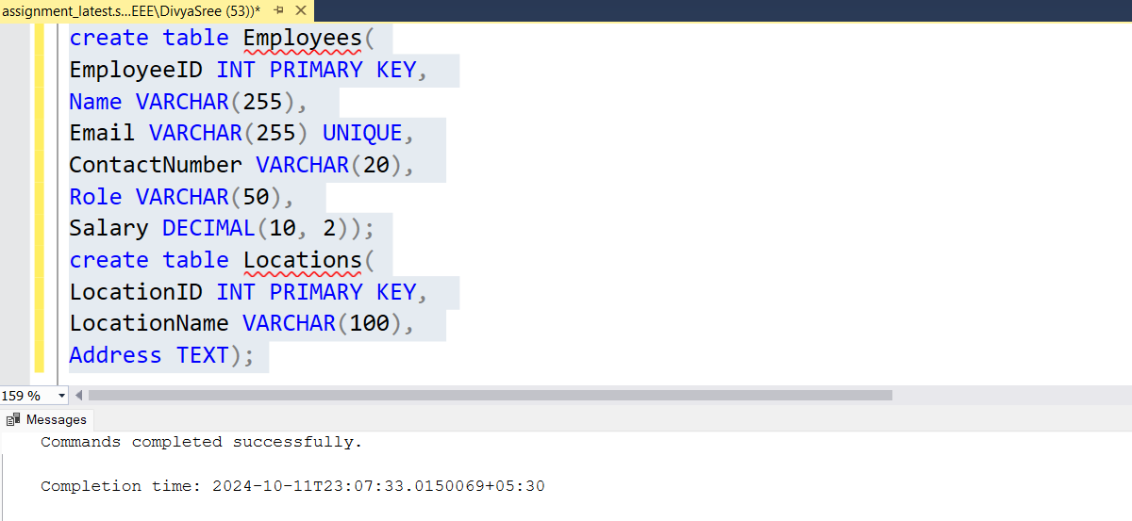

**2.5.Payment Table**

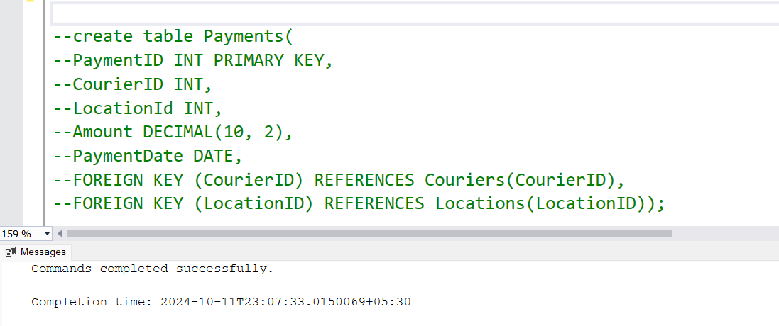

**2.6. Orders Table**

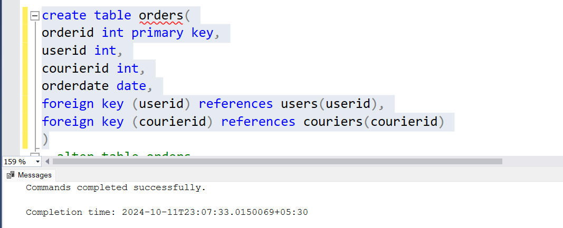

**2.6.1. Creating relation between employees and orders using foreign key**

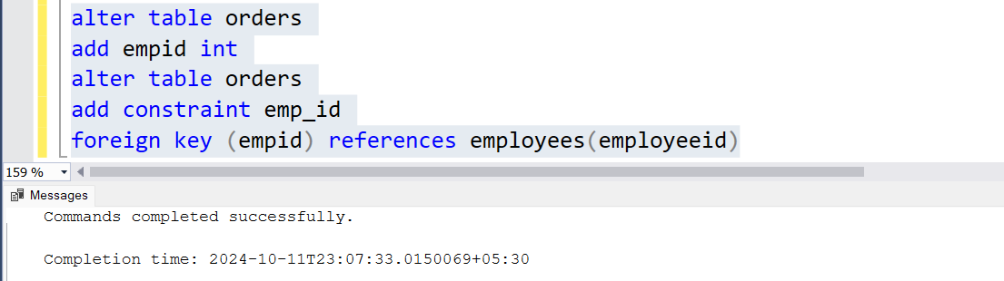

**2.7. Parcels Table**

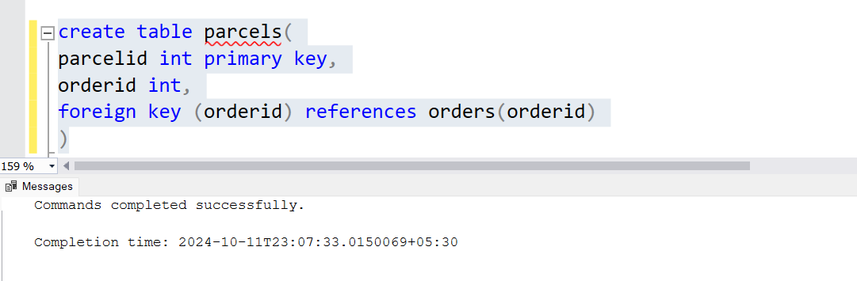

**3.Relationships between these tables**

**One-to-Many:**

* A User can have many Couriers.
* A Location can have many Couriers and Payments.
* An Employee can handle many Couriers.
* A CourierService can have many Couriers.

**Many-to-One Relationships:**

* Orders ↔ Couriers:
  + Many orders can be assigned to the same courier, but each order has only one courier.
* Payments ↔ Locations:
  + Many payments can occur at the same location, but each payment is tied to one location.

For reference, I have attached ER diagram(for reference only)

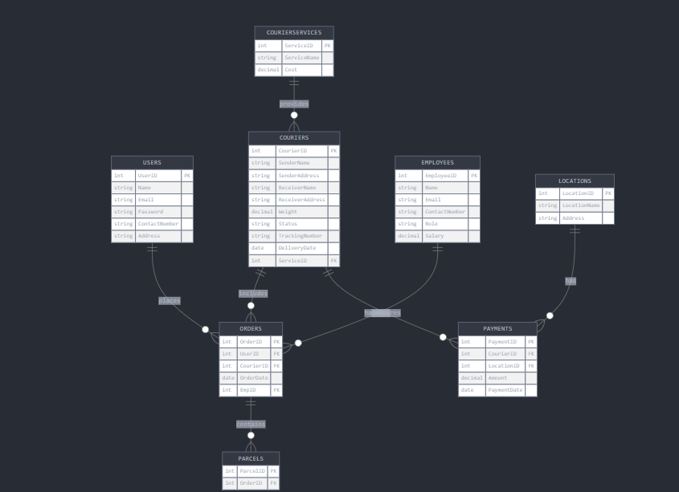

**4.Inserting sample values to each of the tables**

**4.1. Inserting 11 sample users into users table**

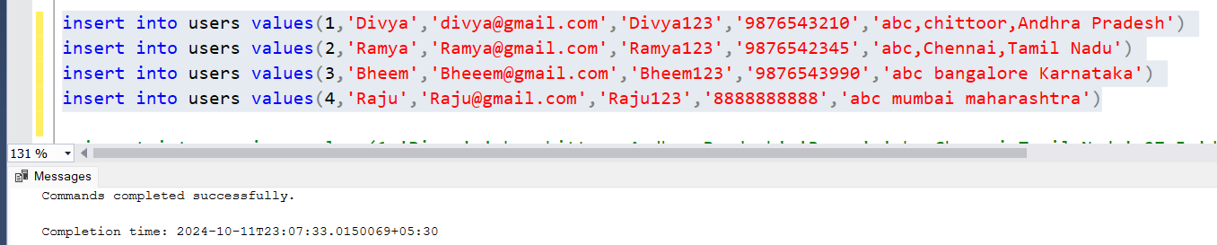

**4.2. Inserting samples into couriers tables**

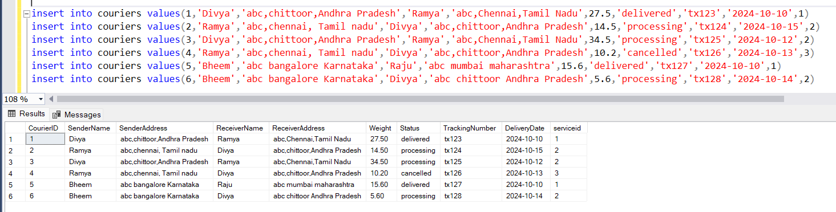

**4.3.Inserting samples into courier services**

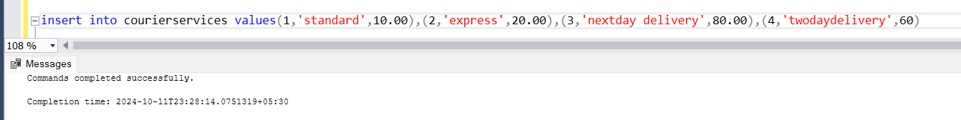

**4.4. Inserting samples into EmployeeTable**

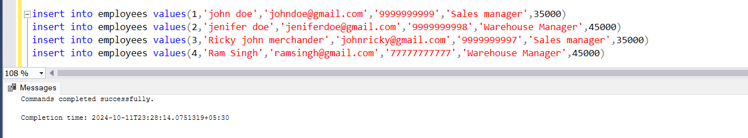

**4.5. Inserting samples into locationTable**

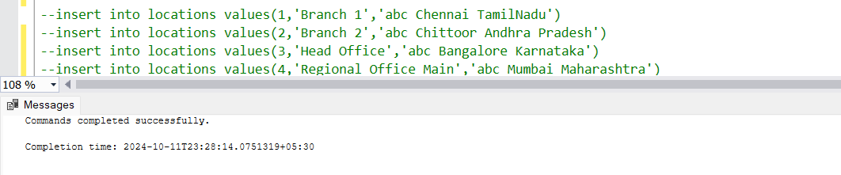

**4.6. Inserting samples into Payment Tables**

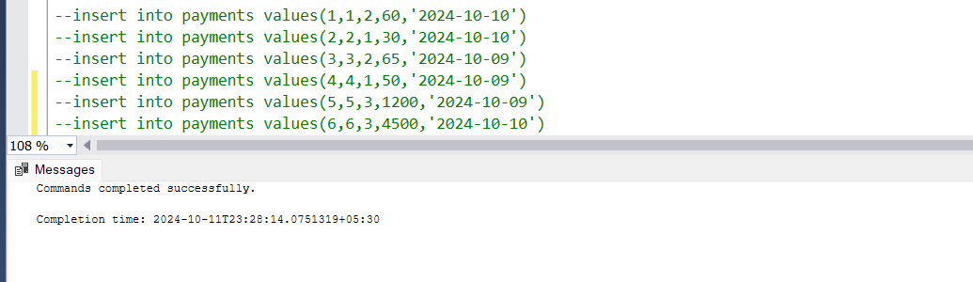

**4.7. Inserting sample data into orders**

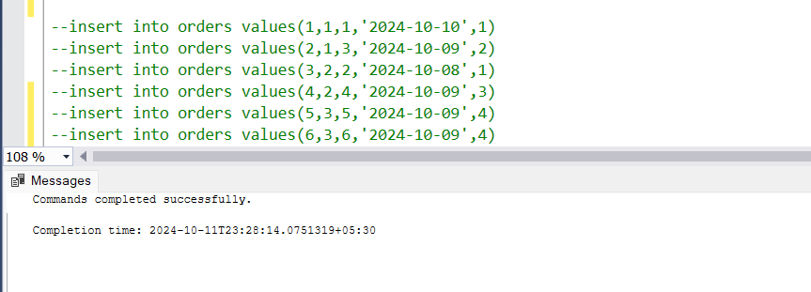

**4.8. Inserting sample data into Parcels**

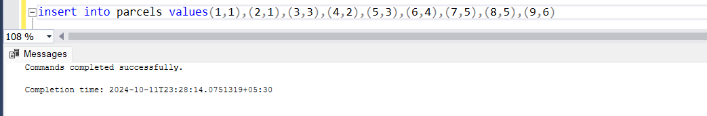

**ASSIGNMENT 4 COURIER MANAGEMENT SYSTEM(TASK_2) DIVYA SREE MURALI**

**TASK_2 DAY 2(29-09-2024)**

**Modified Version(11-10-2024)**

**Considerations:**

**All packages are considered as parcels and All deliveries are considered as couriers**

**USING SELECT,WHERE STATEMENTS**

1. **List all customers:**

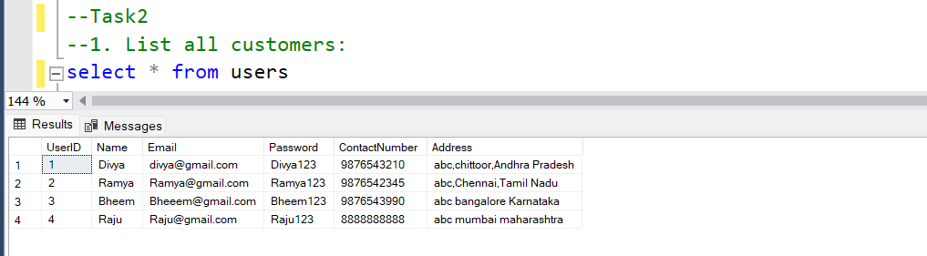

1. **List all orders for a specific customer:**

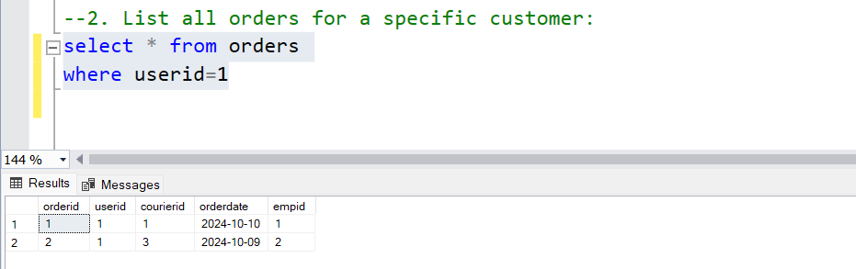

1. **List all couriers**:

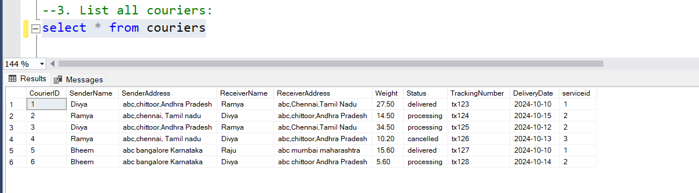

1. **List all packages for a specific order:**

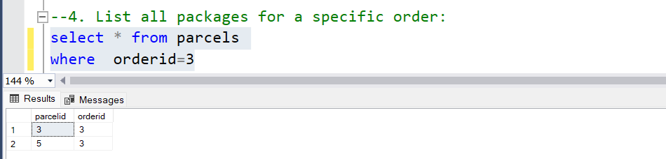

1. **List all deliveries for a specific courier:**

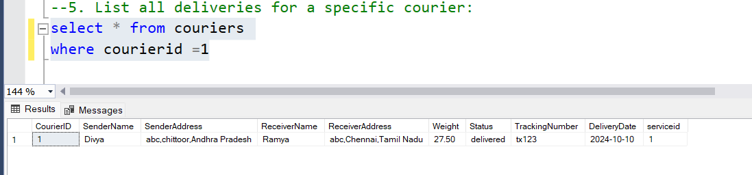

1. **List all undelivered packages:**

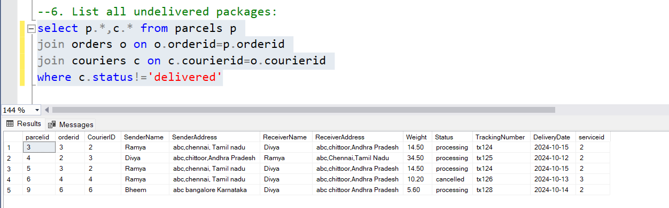

1. **List all packages that are scheduled for delivery today:**

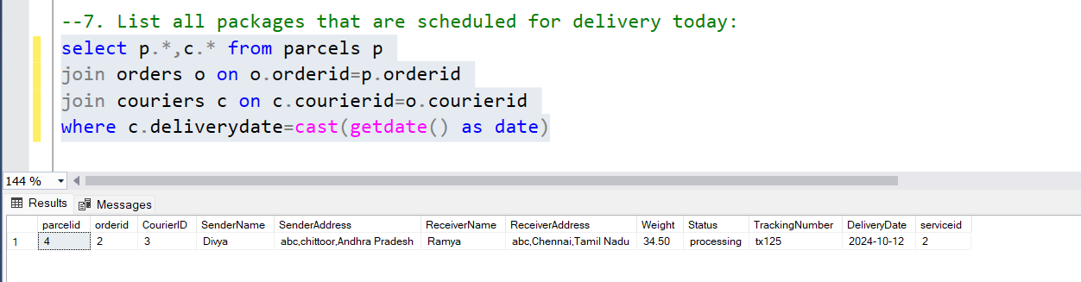

**8.List all packages with a specific status:**

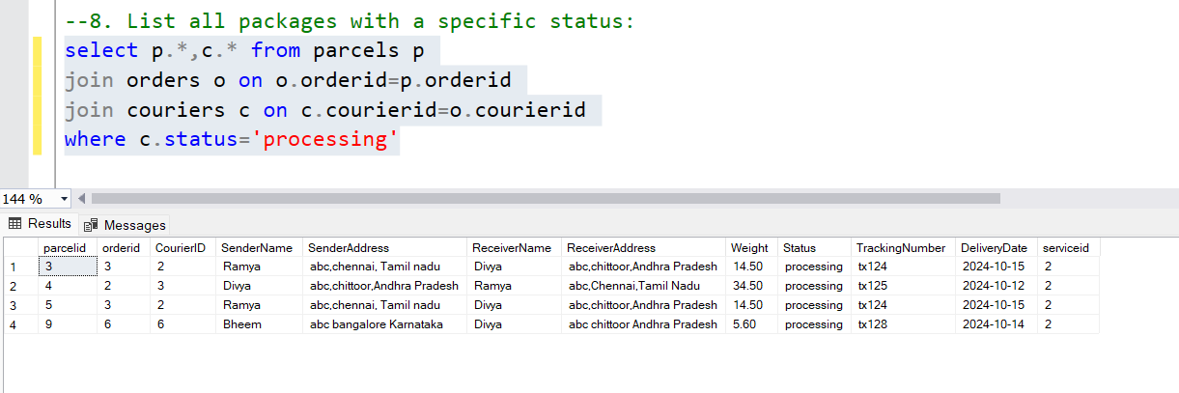

**9.Calculate the total number of packages for each courier.**

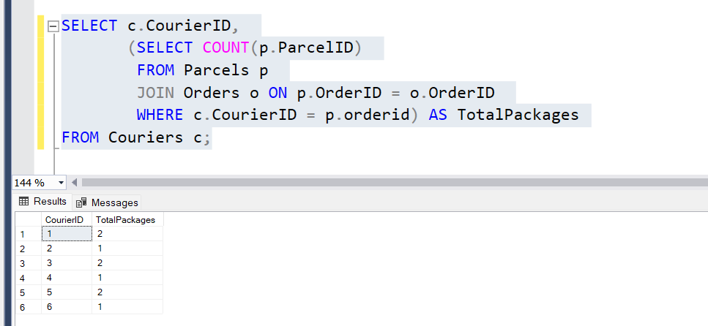

**10. Find the average delivery time for each courier**

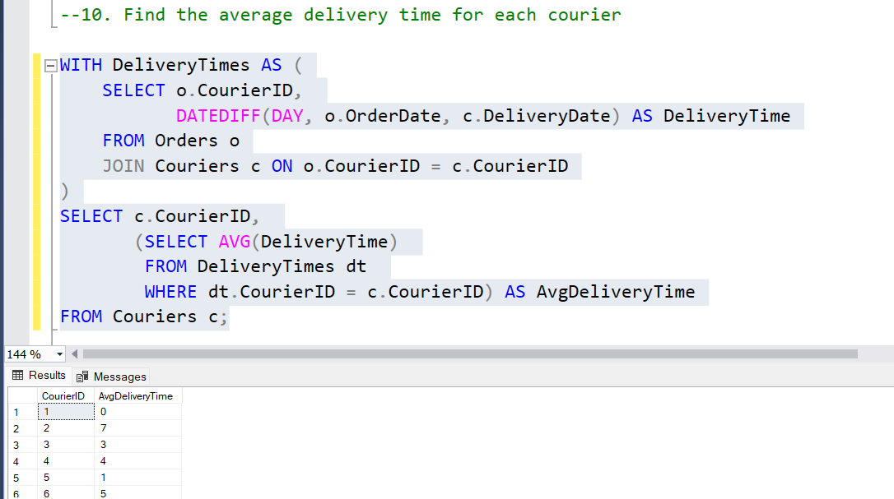

**11. List all packages with a specific weight range:**

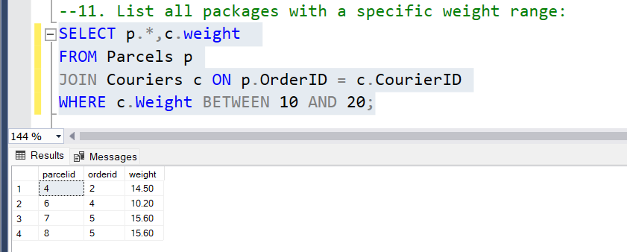

**12. Retrieve employees whose names contain 'John'**

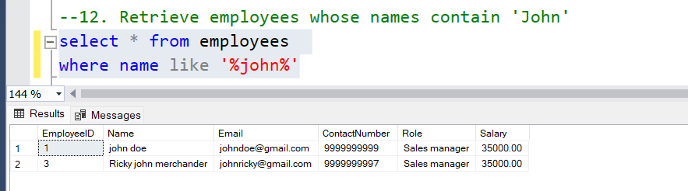

**13. Retrieve all courier records with payments greater than $50.**

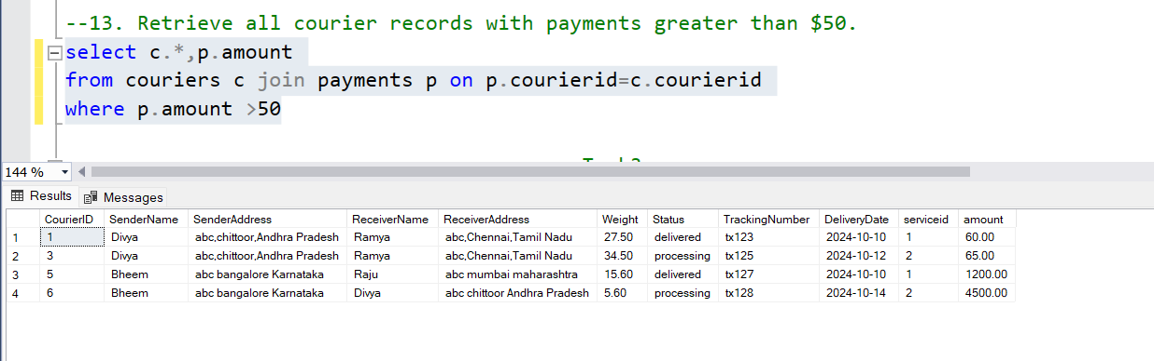

**Assignment 4 Courier Management System(Task3) Divya Sree Murali**

**Task 3(sql) (7/10/2024)**

**Modified (12/10/2024)**

**14. Find the total number of couriers handled by each employee.**

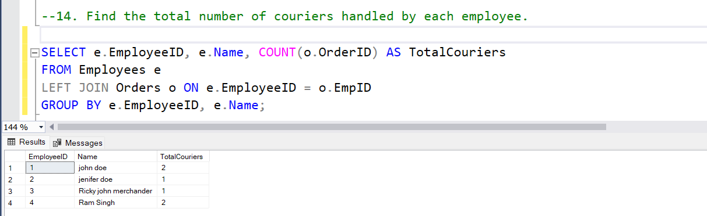

**15. Calculate the total revenue generated by each location**

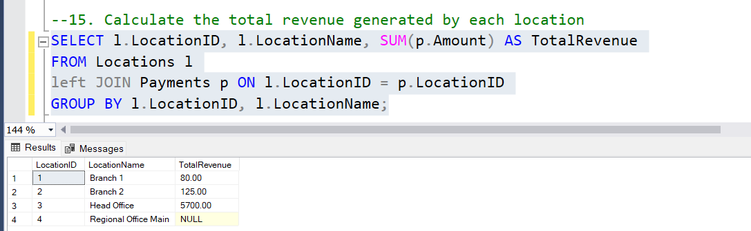

**16. Find the total number of couriers delivered to each location.**

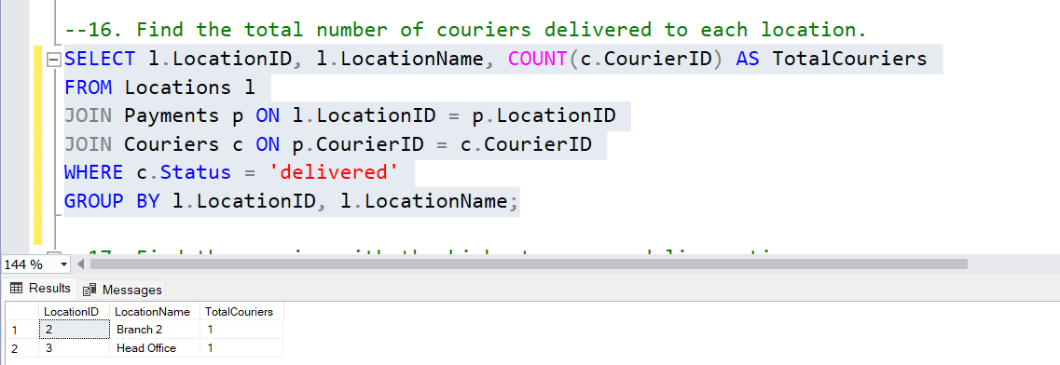

**17. Find the courier with the highest average delivery time:**

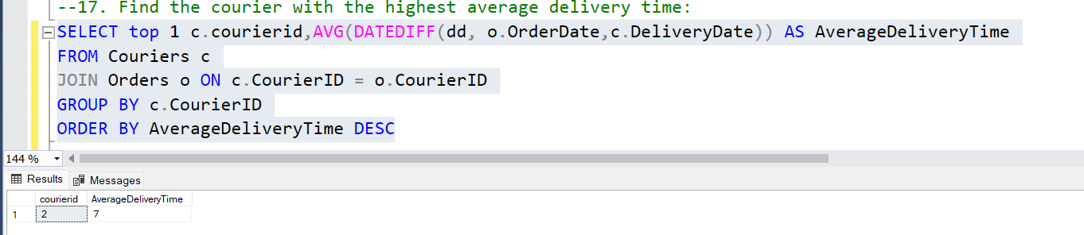

**18. Find Locations with Total Payments Less Than a Certain Amount**

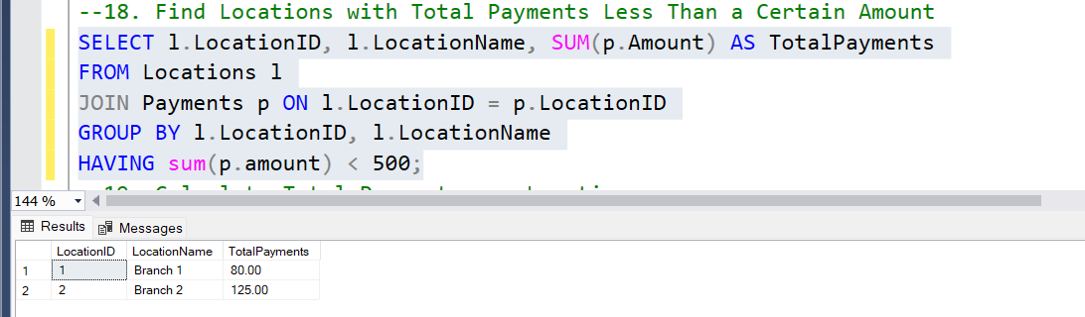

**19. Calculate Total Payments per Location**

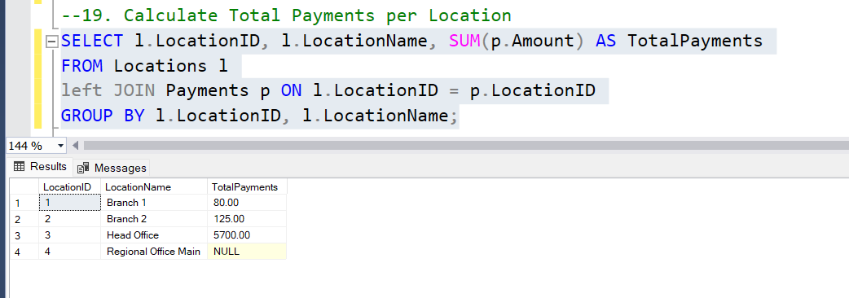

**20. Retrieve couriers who have received payments totaling more than $1000 in a specific location**

**(LocationID = X):**

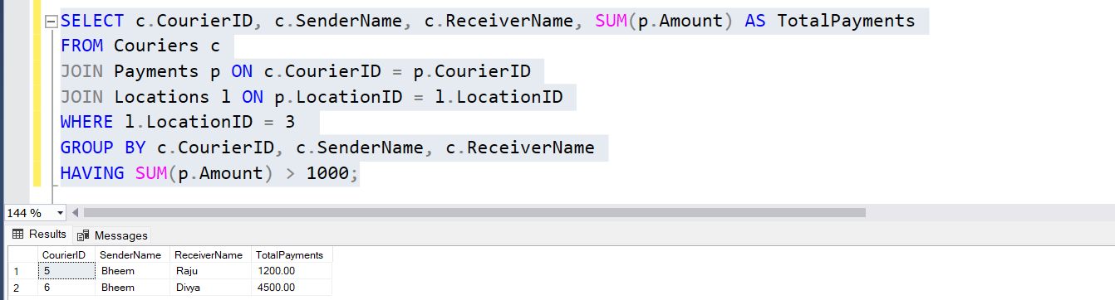

**21. Retrieve couriers who have received payments totaling more than $1000 after a certain date**

**(PaymentDate > 'YYYY-MM-DD'):**

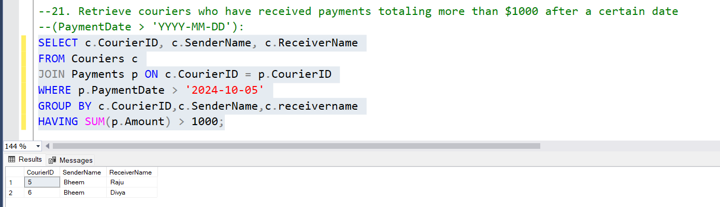

**22. Retrieve locations where the total amount received is more than $5000 before a certain date**

**(PaymentDate > 'YYYY-MM-DD')**

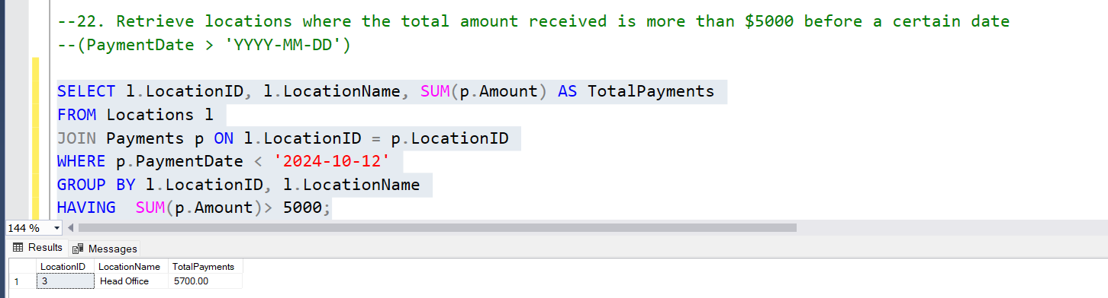

**Assignment 4 Courier Management System (sql) Divya Sree Murali**

**Task 4 (8/10/2024)**

**Modified (12/10/2024)**

**I have doubts in 48 and 49 questions .I will be updating it soon**

**23. Retrieve Payments with Courier Information**

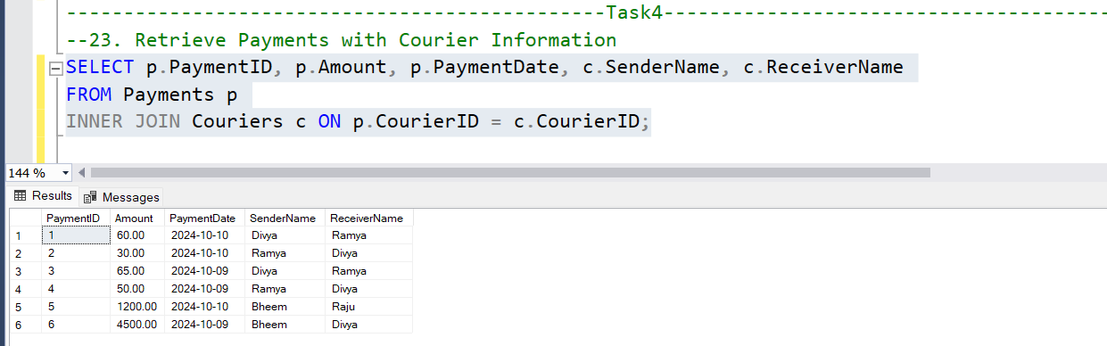

**24. Retrieve Payments with Location Information**

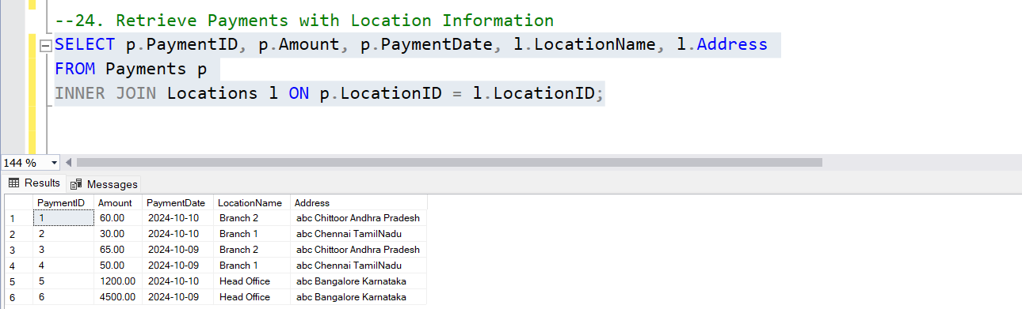

**25. Retrieve Payments with Courier and Location Information**

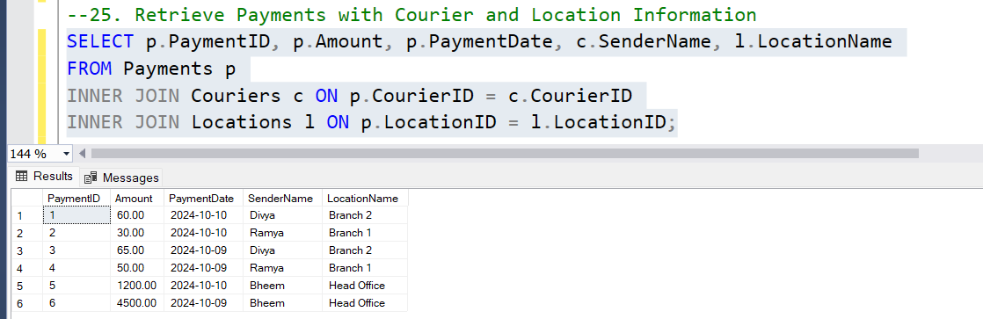

**26. List all payments with courier details**

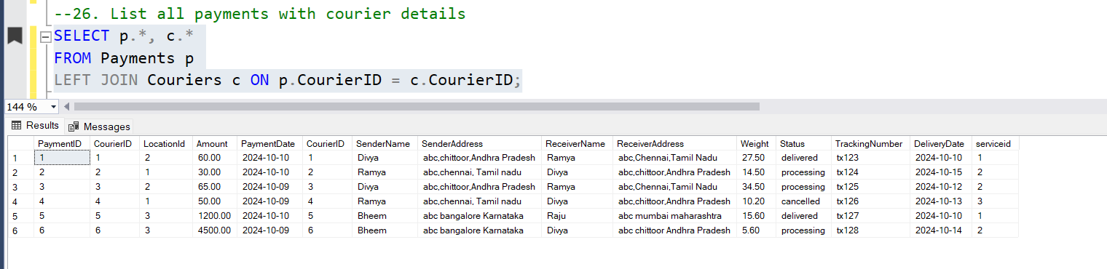

**27. Total payments received for each courier**

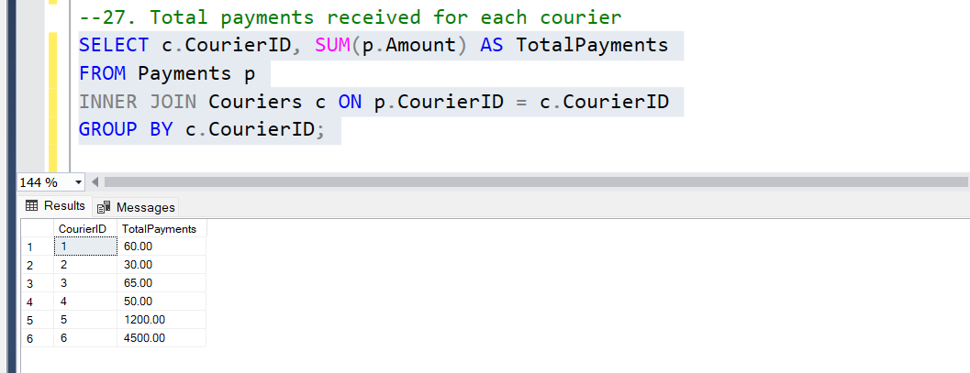

**28. List payments made on a specific date**

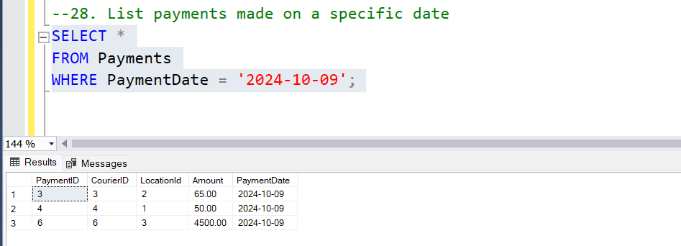

**29. Get Courier Information for Each Payment**

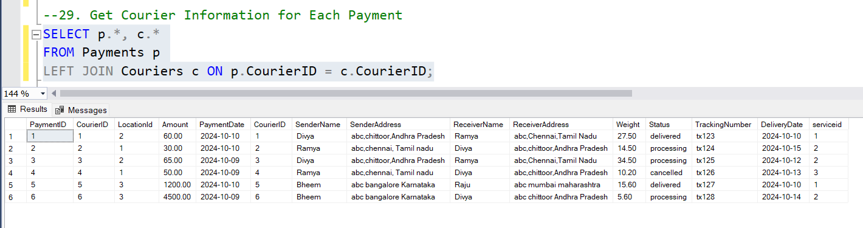

**30. Get Payment Details with Location**

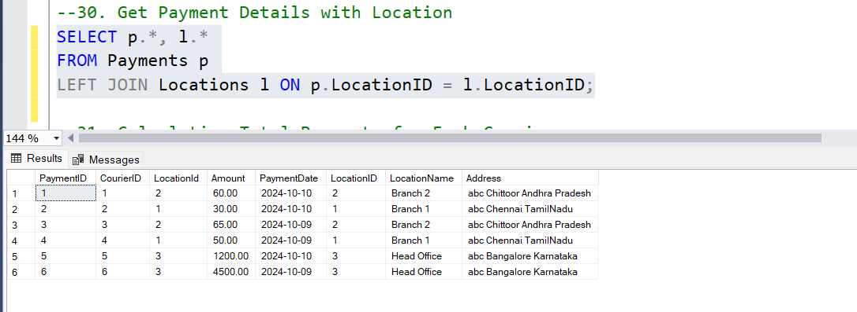

**31. Calculating Total Payments for Each Courier**

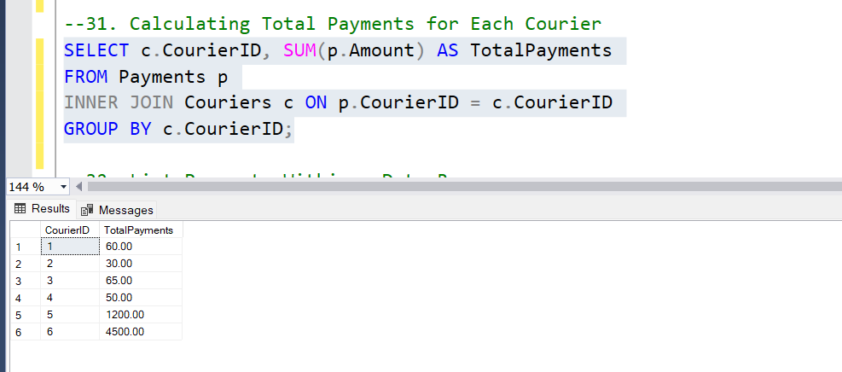

**32. List Payments Within a Date Range**

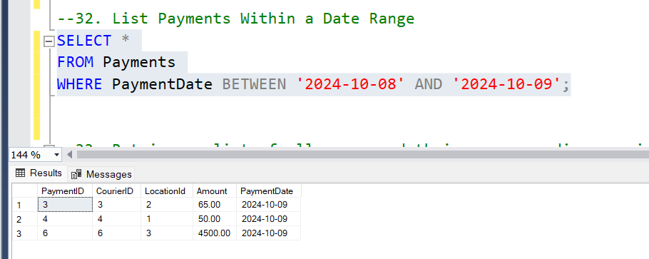

**33. Retrieve a list of all users and their corresponding courier records, including cases where there are no matches on either side**

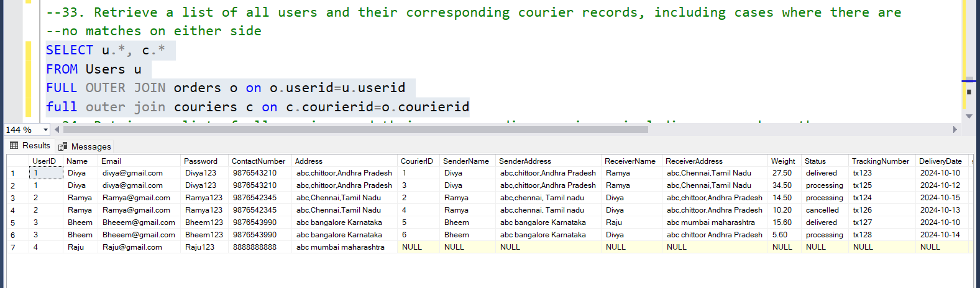

**34. Retrieve a list of all couriers and their corresponding services, including cases where there are no matches on either side**

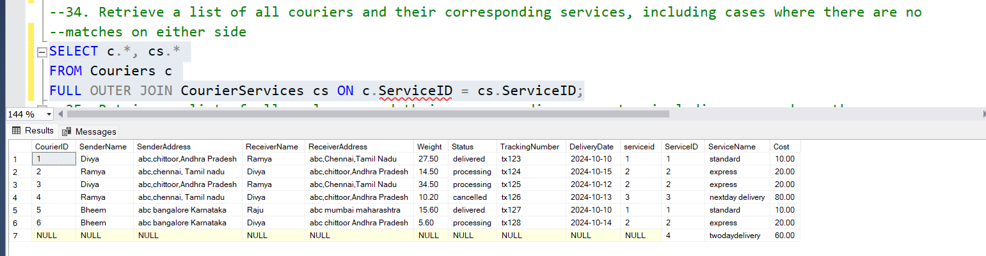

**35. Retrieve a list of all employees and their corresponding payments, including cases where there are no matches on either side**

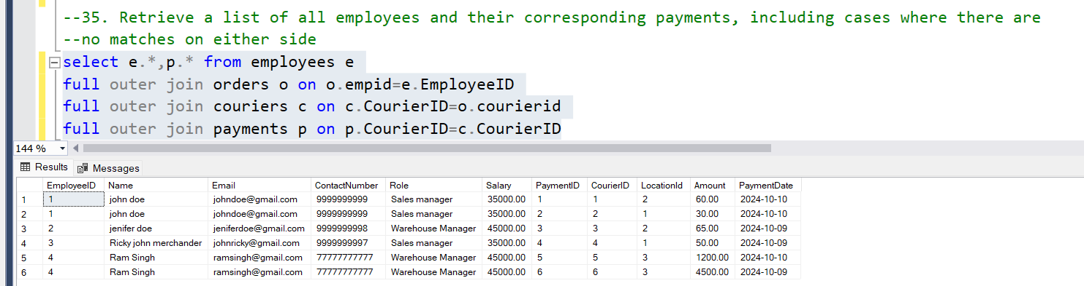

**36. List all users and all courier services, showing all possible combinations.**

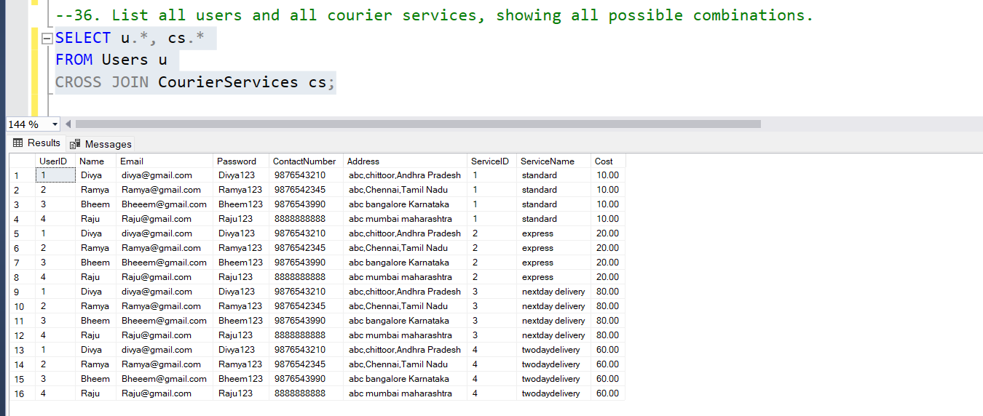

**37. List all employees and all locations, showing all possible combinations:**

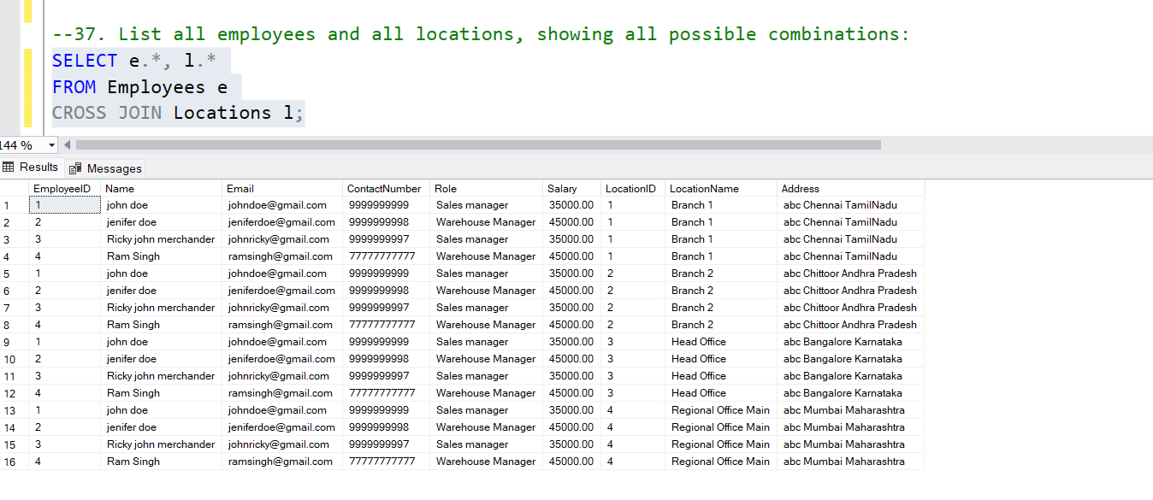

**38. Retrieve a list of couriers and their corresponding sender information (if available)**

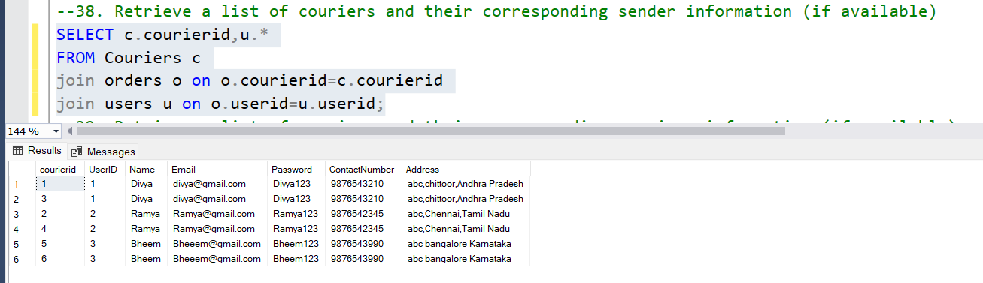

**39. Retrieve a list of couriers and their corresponding receiver information (if available):**

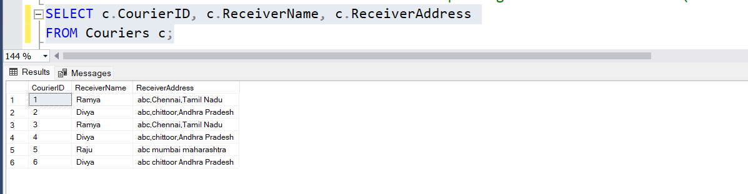

**40. Retrieve a list of couriers along with the courier service details (if available):**

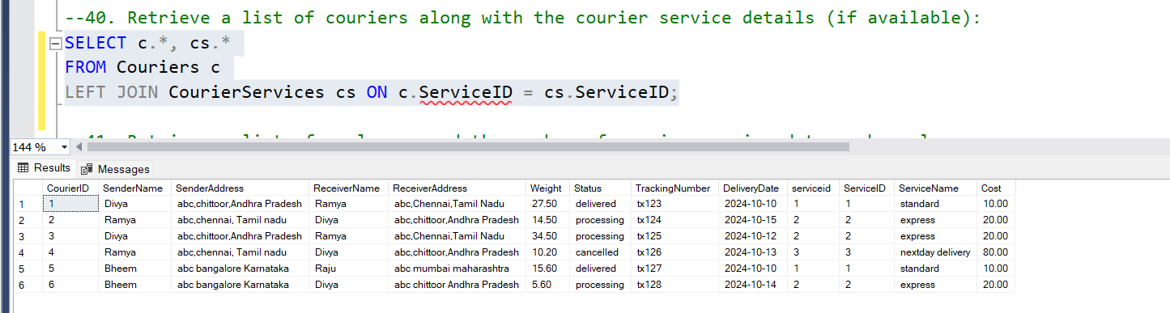

**41. Retrieve a list of employees and the number of couriers assigned to each employee:**

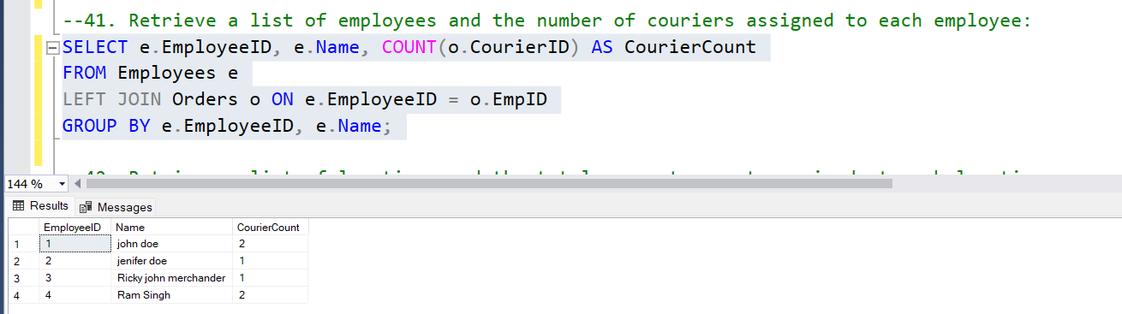

**42. Retrieve a list of locations and the total payment amount received at each location:**

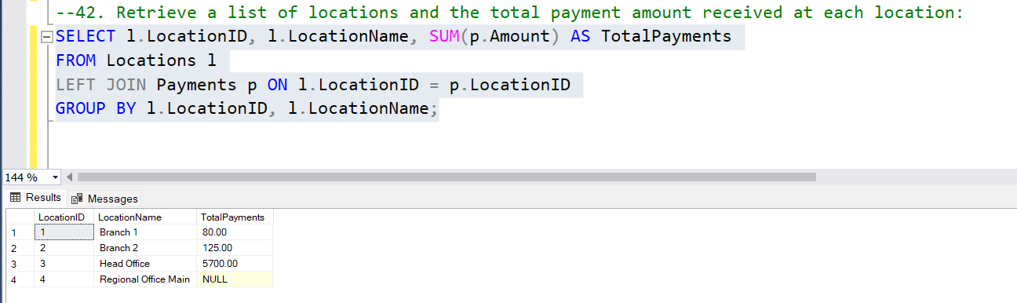

**43. Retrieve all couriers sent by the same sender (based on SenderName).**

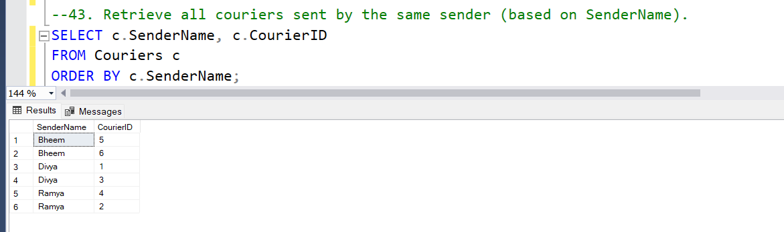

**44. List all employees who share the same role.**

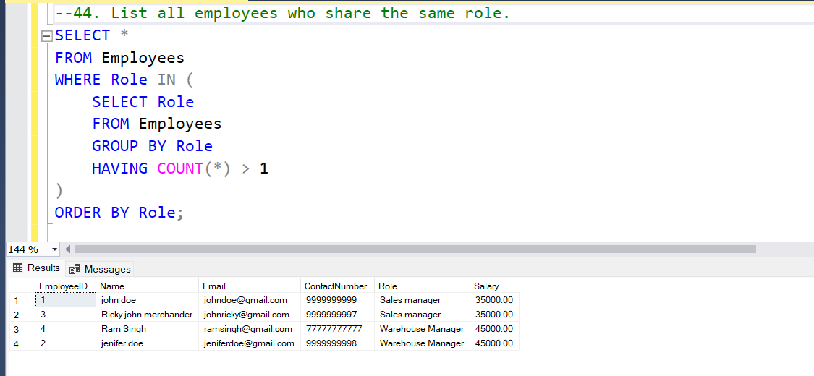

**45. Retrieve all payments made for couriers sent from the same location.**

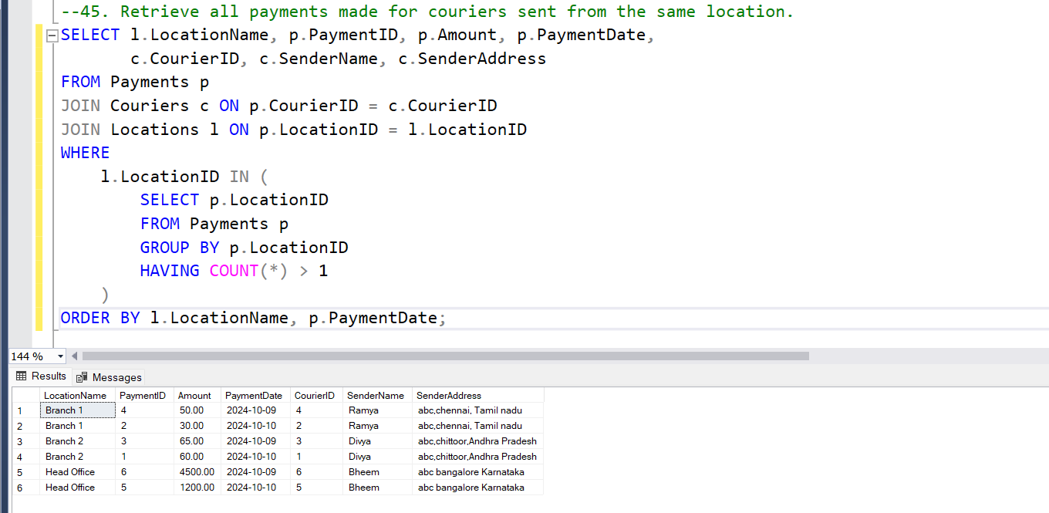

**46. Retrieve all couriers sent from the same location (based on SenderAddress).**

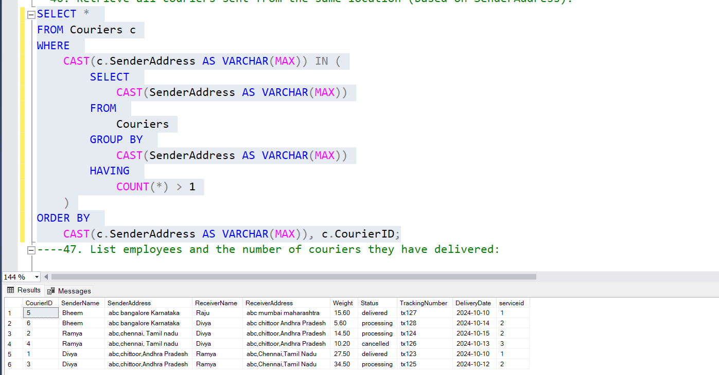

**47. List employees and the number of couriers they have delivered:**

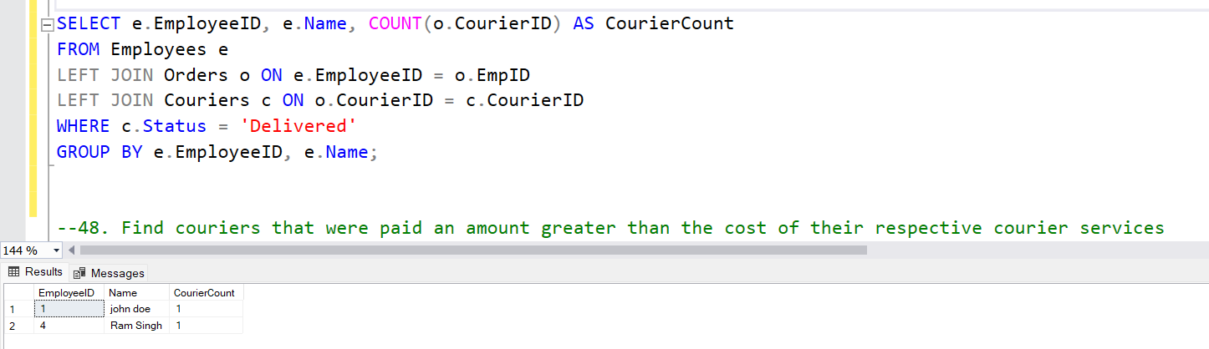

**48. Find couriers that were paid an amount greater than the cost of their respective courier services**

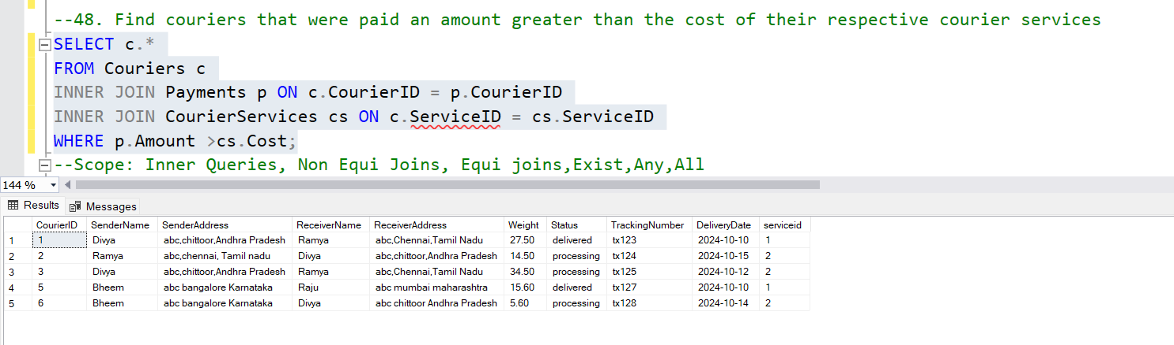

**Scope: Inner Queries, Non Equi Joins, Equi joins,Exist,Any,All**

**49. Find couriers that have a weight greater than the average weight of all couriers**

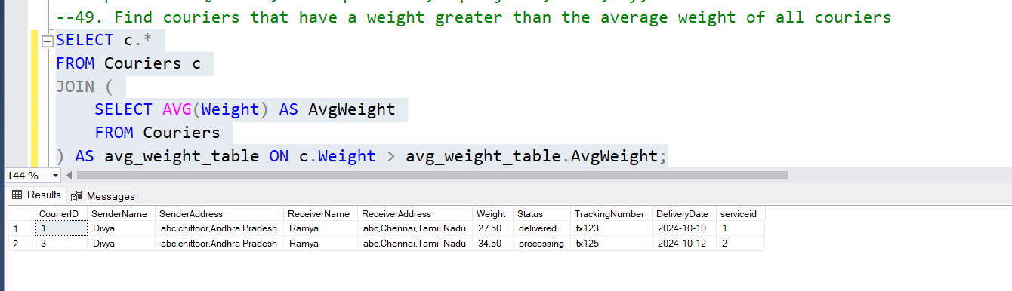

**50. Find the names of all employees who have a salary greater than the average salary:**

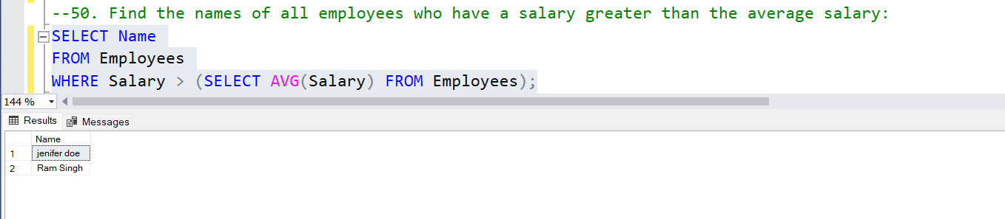

**51. Find the total cost of all courier services where the cost is less than the maximum cost**

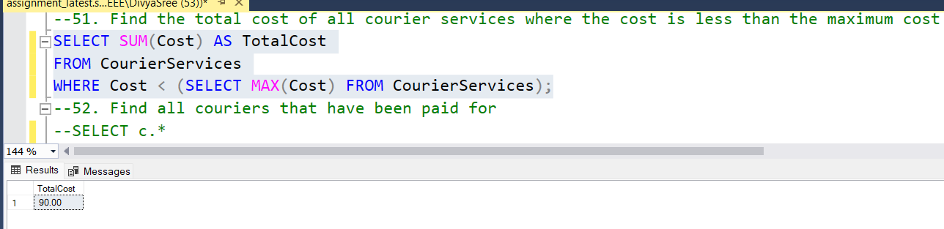

**52. Find all couriers that have been paid for**

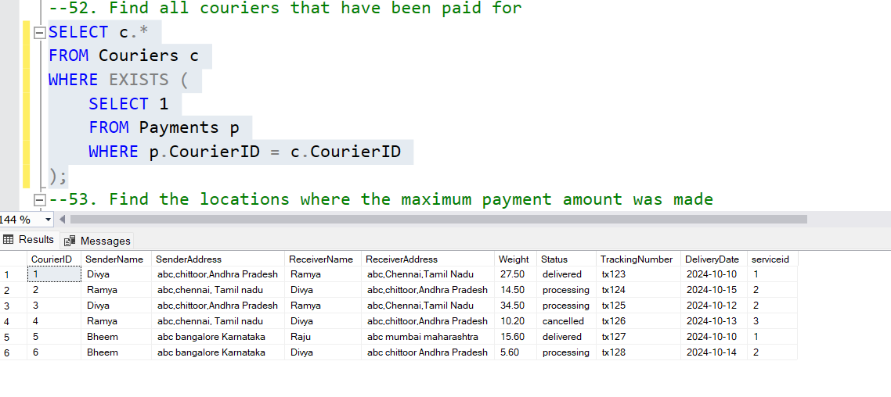

**53. Find the locations where the maximum payment amount was made**

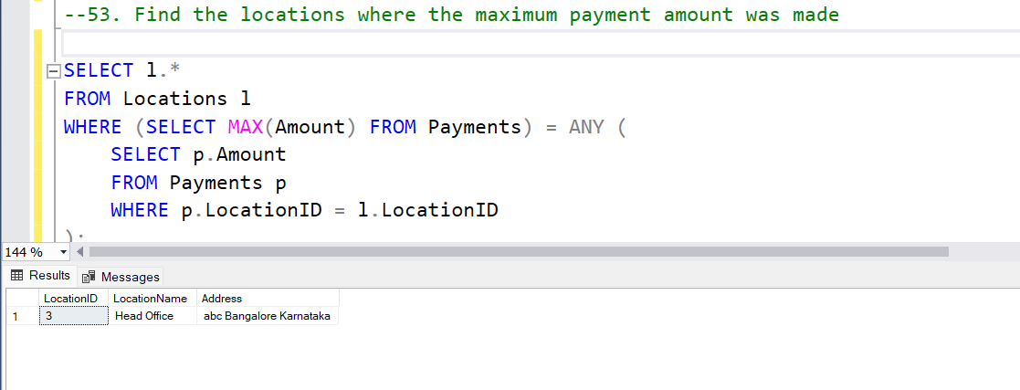

**54. Find all couriers whose weight is greater than the weight of all couriers sent by a specific sender**

**(e.g., 'SenderName'):**

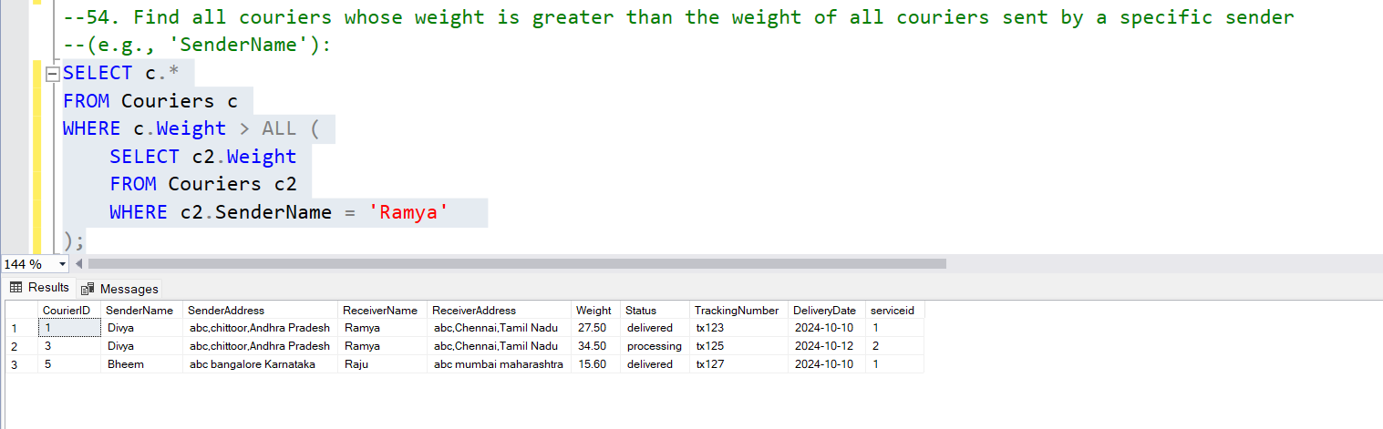

**CODING TASK1: Control flow Statements**

**1. Write a program that checks whether a given order is delivered or not based on its status (e.g.,**

**"Processing," "Delivered," "Cancelled"). Use if-else statements for this.**

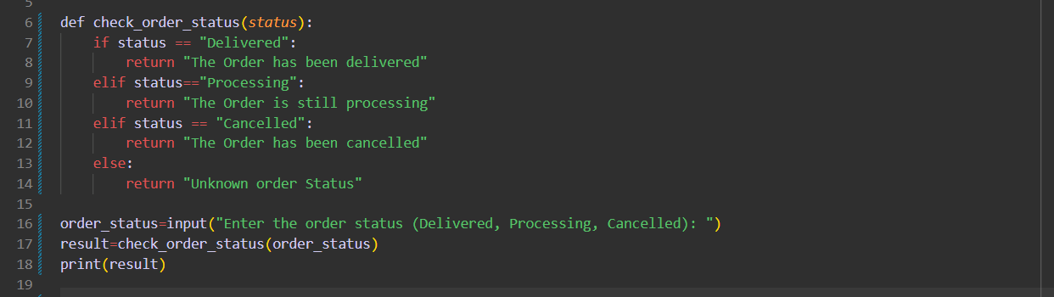

* 1. **Output**

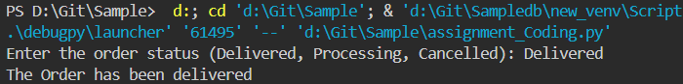

**2. Implement a switch-case statement to categorize parcels based on their weight into "Light,"**

**"Medium," or "Heavy."**

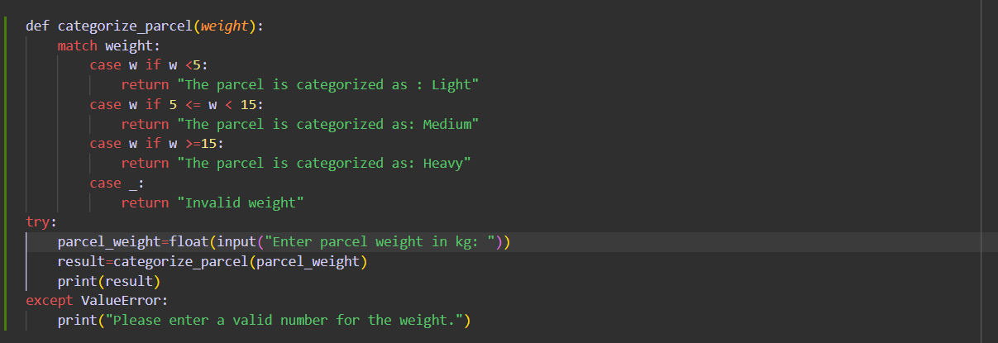

* 1. **Output**

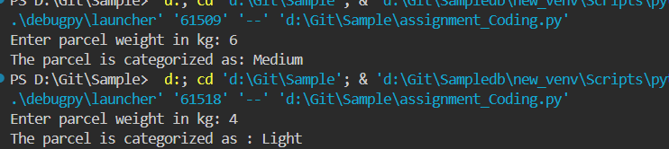

**3.Implement User Authentication 1. Create a login system for employees and customers using python control flow statements.**

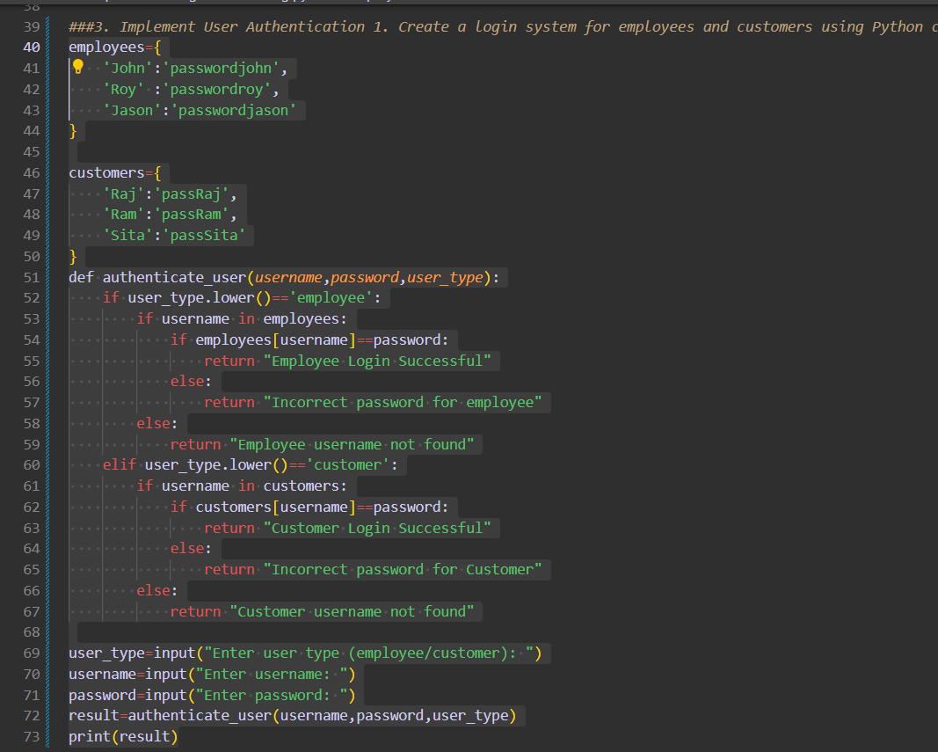

**3.1.Output**

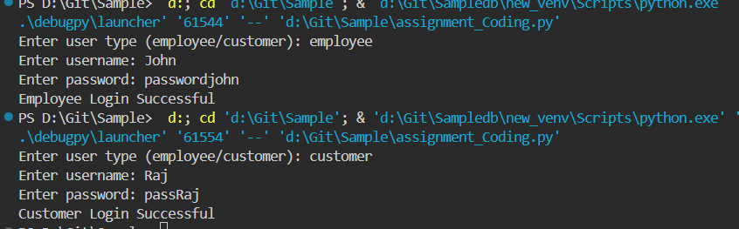

**4. Implement Courier Assignment Logic 1. Develop a mechanism to assign couriers to shipments based on predefined criteria (e.g., proximity, load capacity) using loops.**

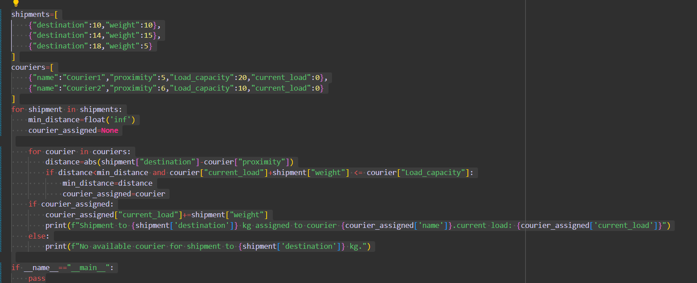

**4.1.Output**

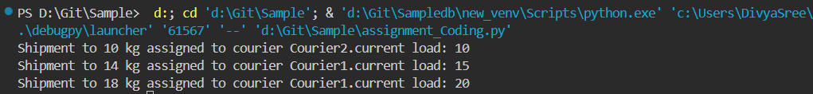

**Coding Task 2**

**5. Write a Python program that uses a for loop to display all the orders for a specific customer.Output has also been attached**

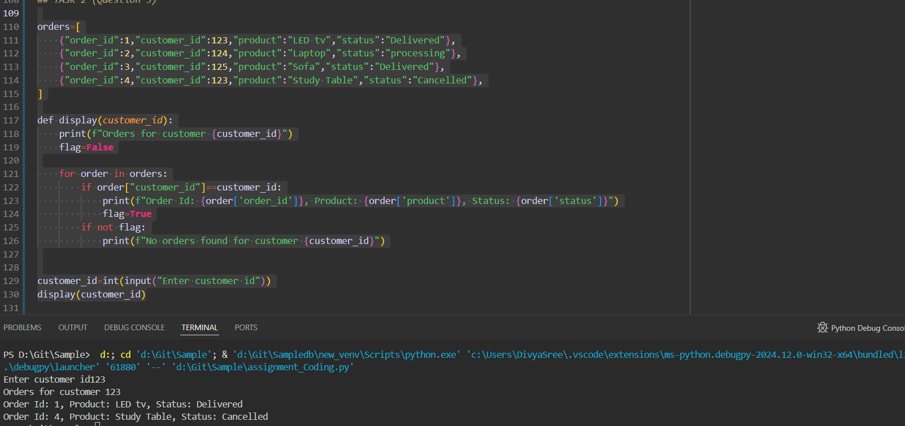

**6. Implement a while loop to track the real-time location of a courier until it reaches its destination.**

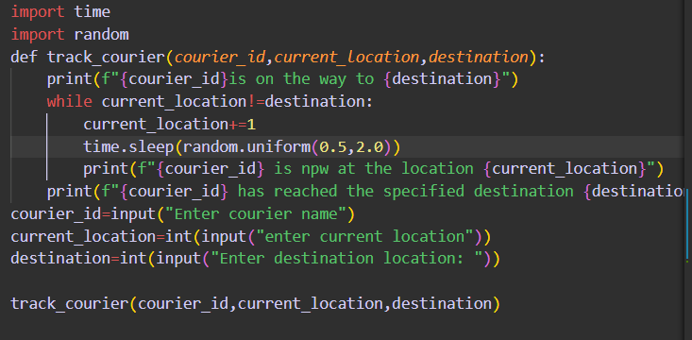

**6.1. Output**

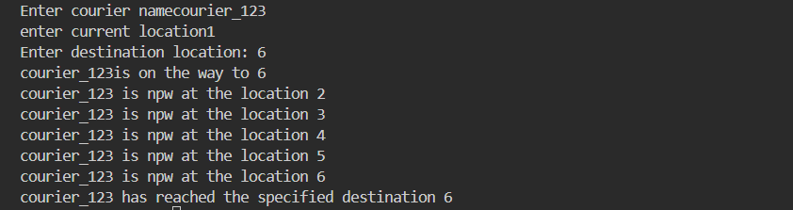

**Coding Task 3: Arrays and Data Structures**

**7. Create an array to store the tracking history of a parcel, where each entry represents a location**

**update.** 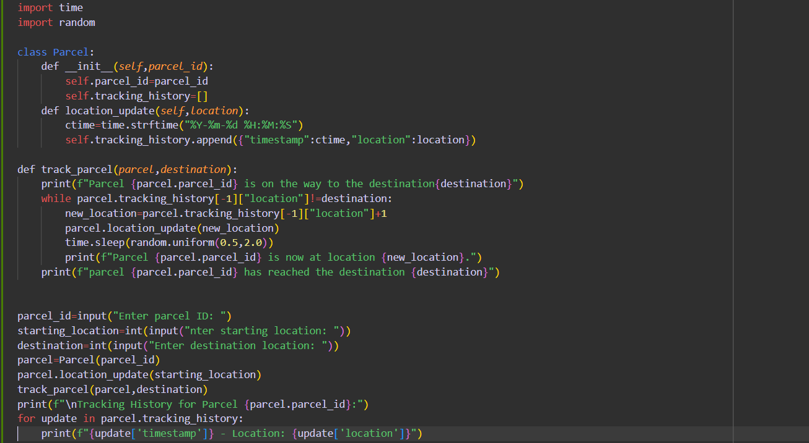

**7.1.Output**

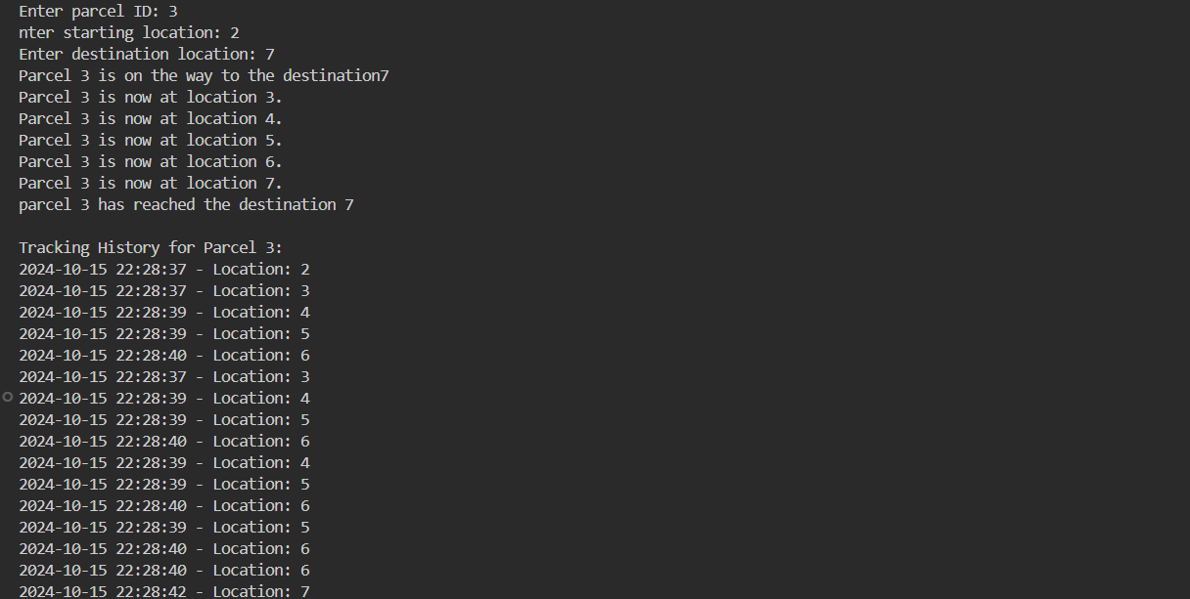

1. **Implement a method to find the nearest available courier for a new order using an array of couriers.**

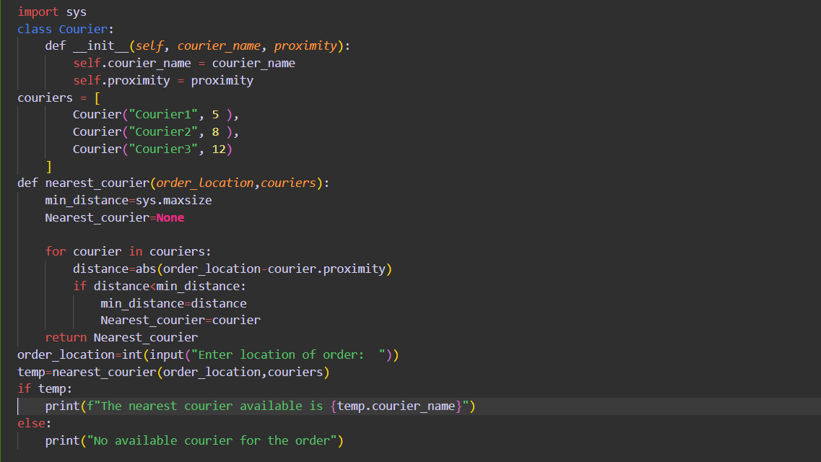

* 1. **Output**

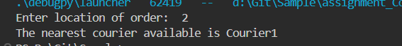

**Coding Task 4**

1. **Parcel Tracking: Create a program that allows users to input a parcel tracking number.Store the tracking number and Status in 2d String Array. Initialize the array with values. Then, simulate the tracking process by displaying messages like "Parcel in transit," "Parcel out for delivery," or "Parcel delivered" based on the tracking number's status.**

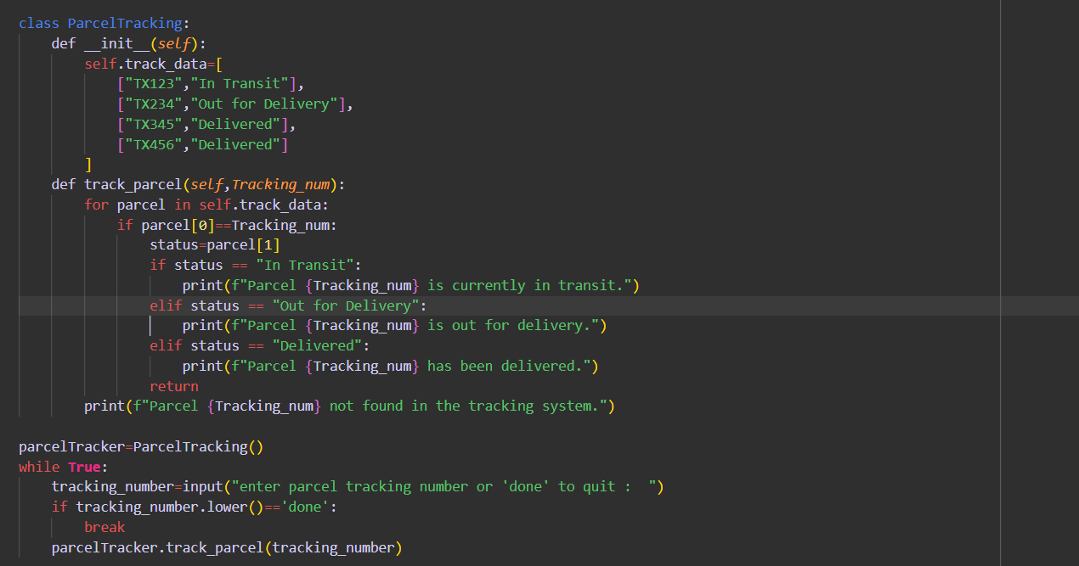

* 1. **Output**

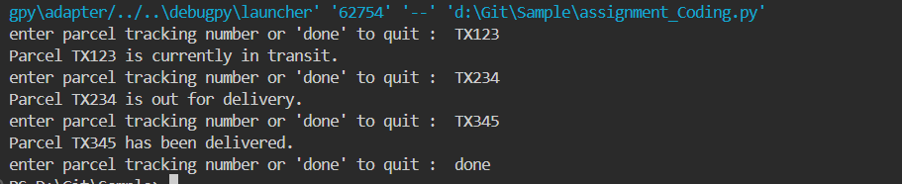

**10.Customer Data Validation: Write a function which takes 2 parameters, data-denotes the data and detail-denotes if it is name address or phone number.Validate customer information based on following critirea. Ensure that names contain only letters and are properly capitalized, addresses do not contain special characters, and phone numbers follow a specific format (e.g., ###-###-####).**

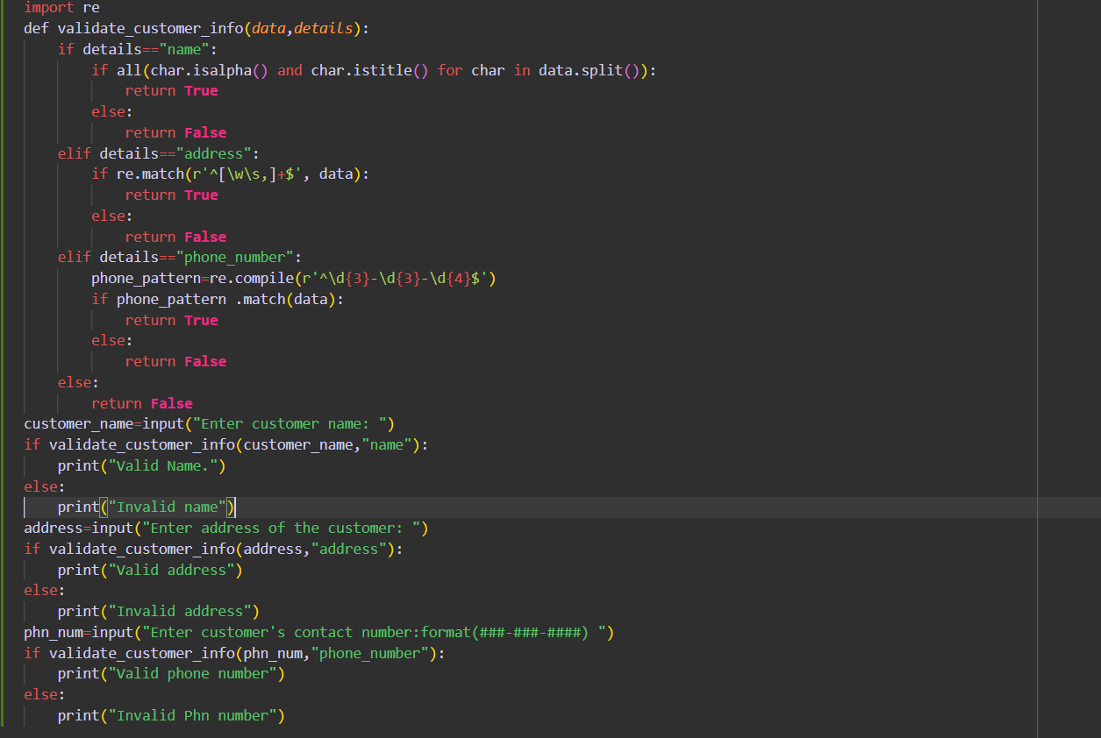

**10.1.Output**

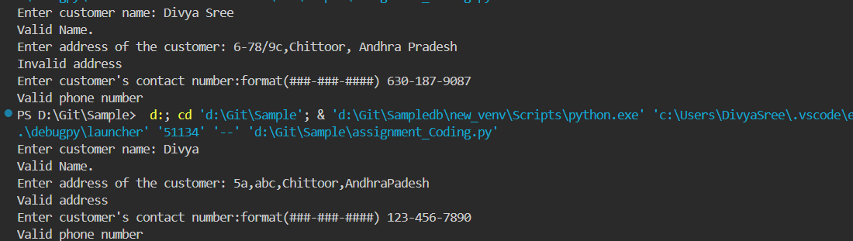

**11. Address Formatting: Develop a function that takes an address as input (street, city, state, zip code) and formats it correctly, including capitalizing the first letter of each word and properly formatting the zip code.**

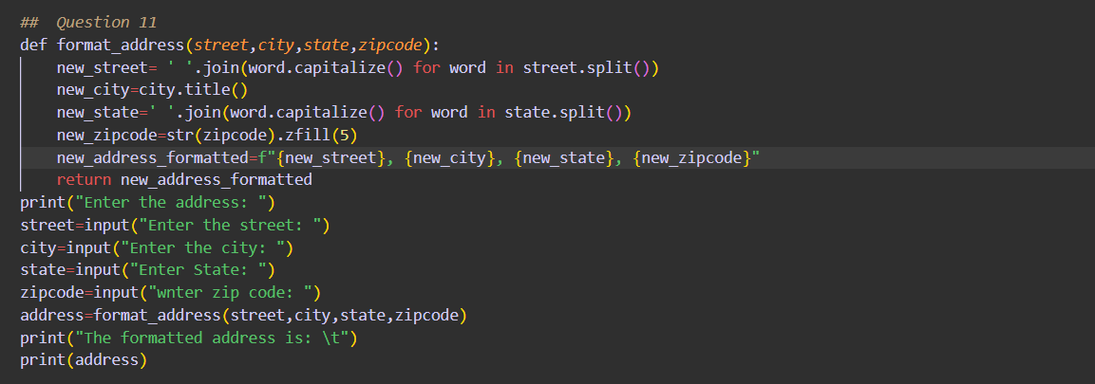

**11.1. Output**

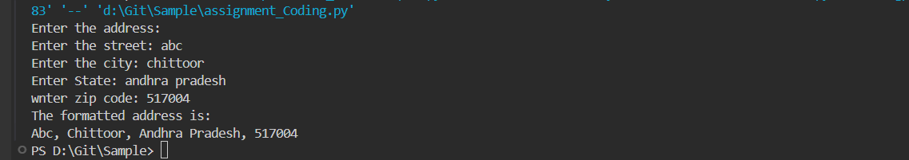

**12. Order Confirmation Email: Create a program that generates an order confirmation email. The email should include details such as the customer's name, order number, delivery address, and expected delivery date.**

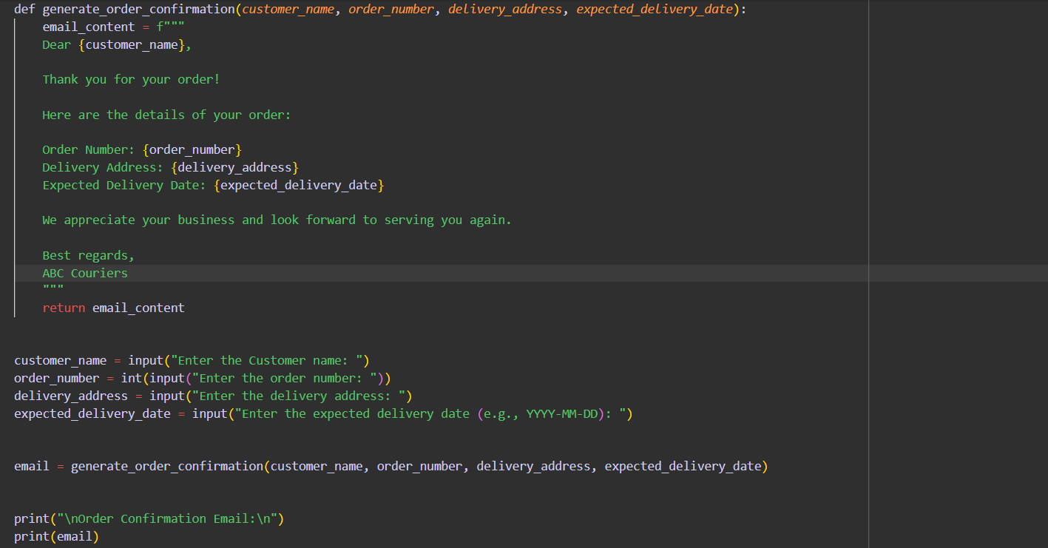

**12.1.Output**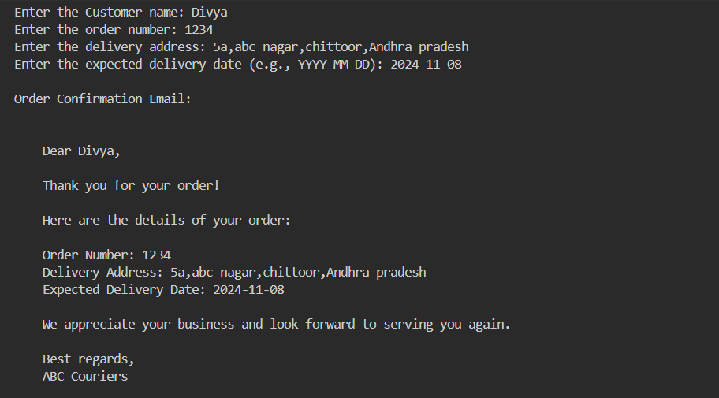

**13. Calculate Shipping Costs: Develop a function that calculates the shipping cost based on the distance between two locations and the weight of the parcel. You can use string inputs for the source and destination addresses.** 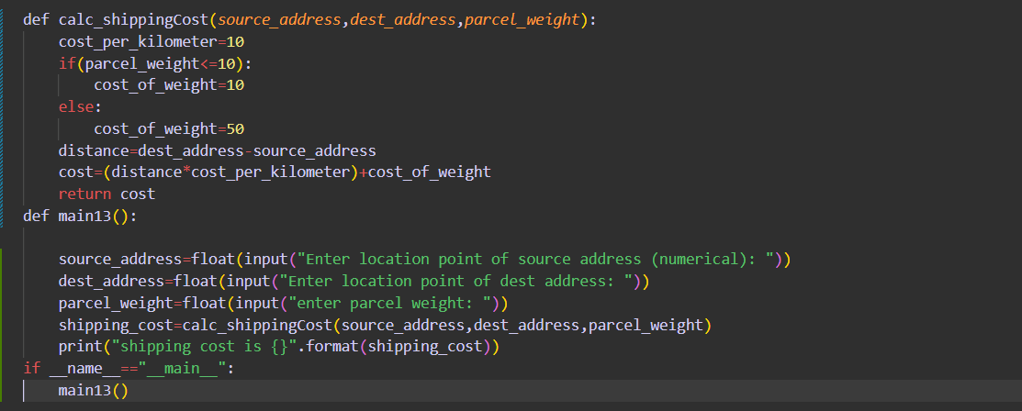

**13.1.Output**

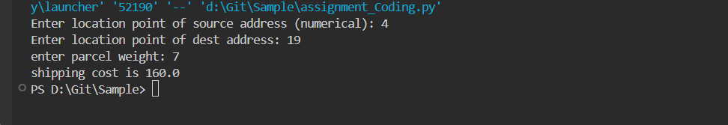

**14. Password Generator: Create a function that generates secure passwords for courier system**

**accounts. Ensure the passwords contain a mix of uppercase letters, lowercase letters,numbers, and special characters.**

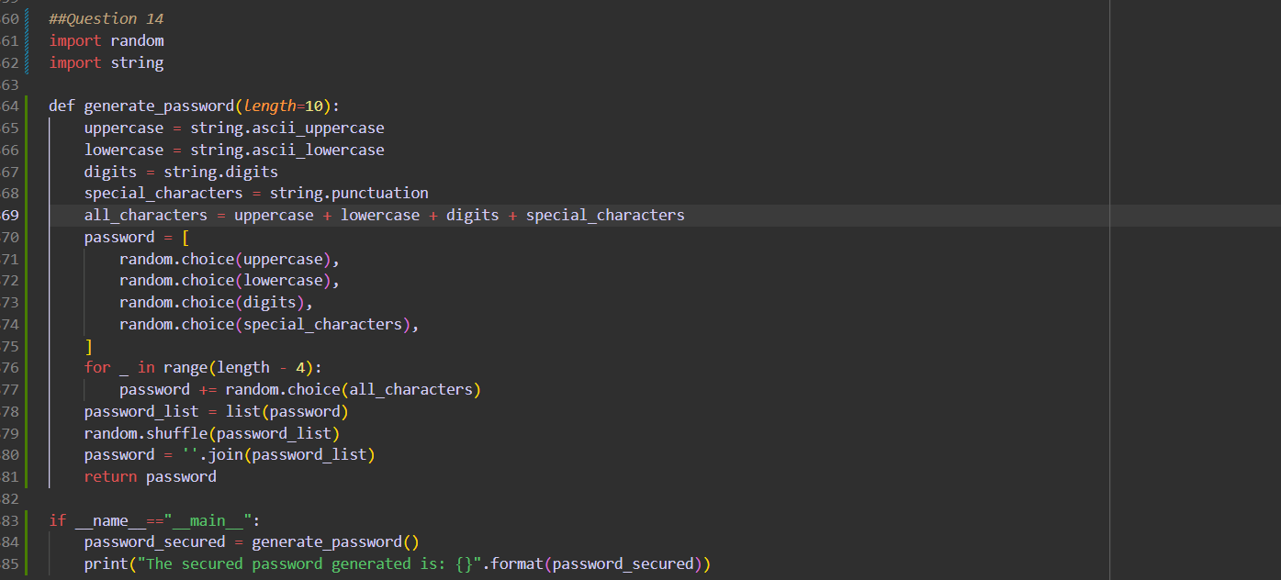

**14.1.Output**

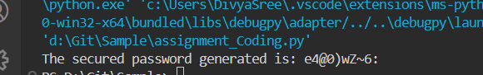

**15. Find Similar Addresses: Implement a function that finds similar addresses in the system. This can be useful for identifying duplicate customer entries or optimizing delivery routes.Use string functions to implement this.**

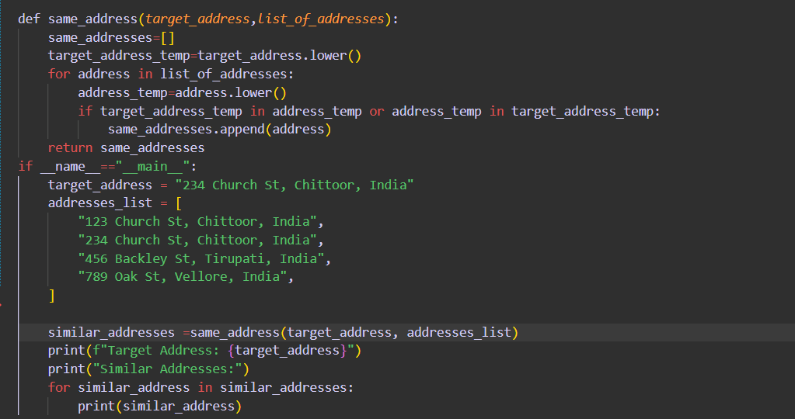

**15.1.Output**

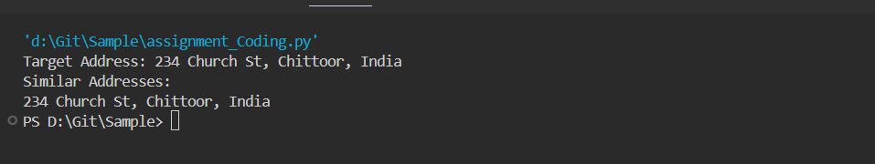

**Task 5: Object Oriented Programming**

**1. User Class:**

**Variables: userID , userName , email , password , contactNumber , address**

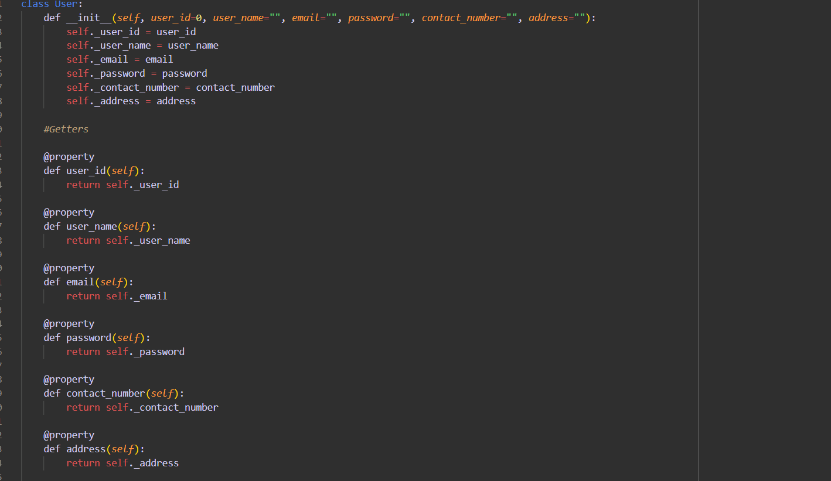

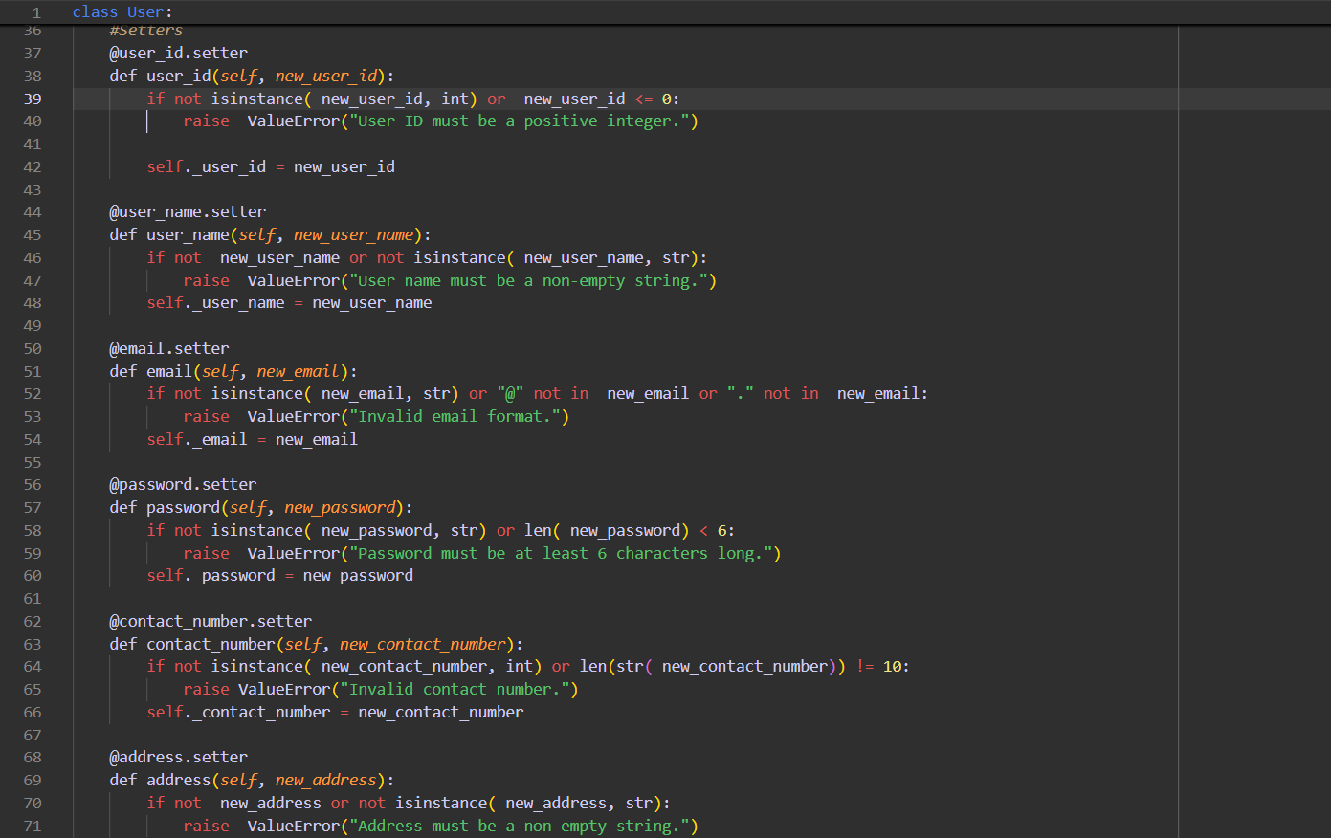

**2. Courier Class**

**Variables: courierID , senderName , senderAddress , receiverName , receiverAddress , weight ,**

**status, trackingNumber , deliveryDate ,userId**

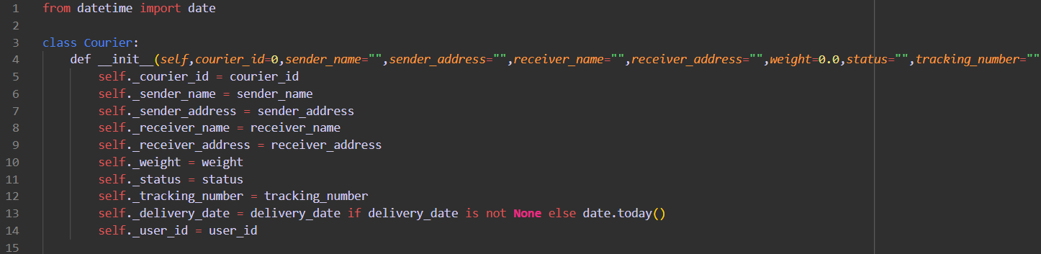

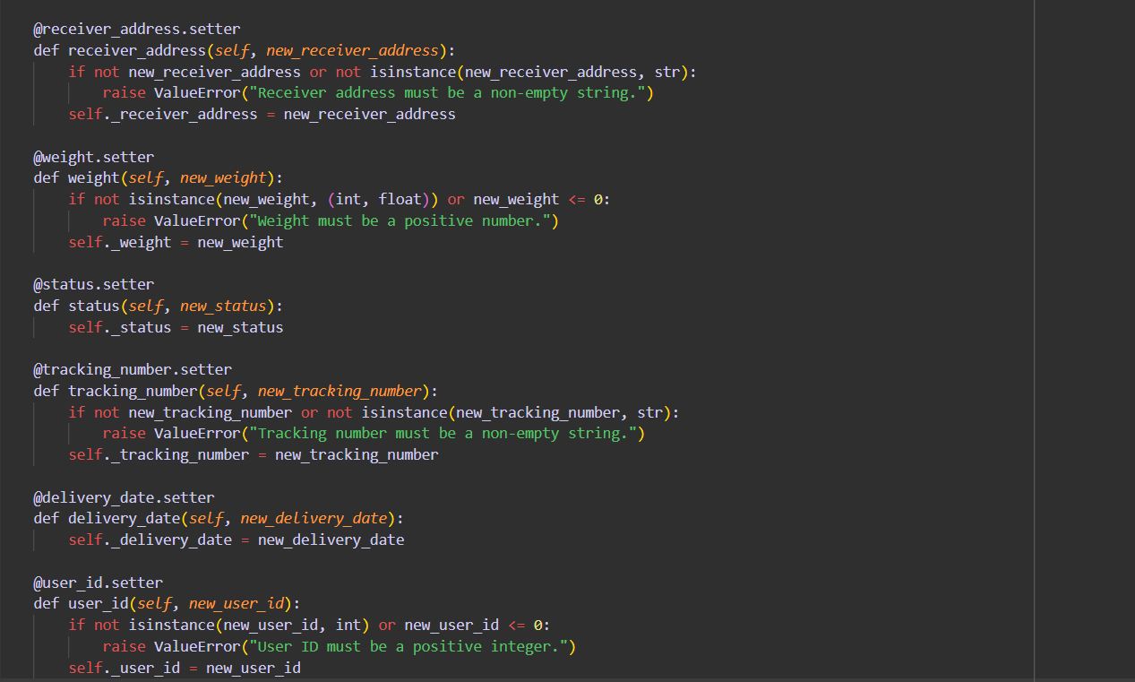

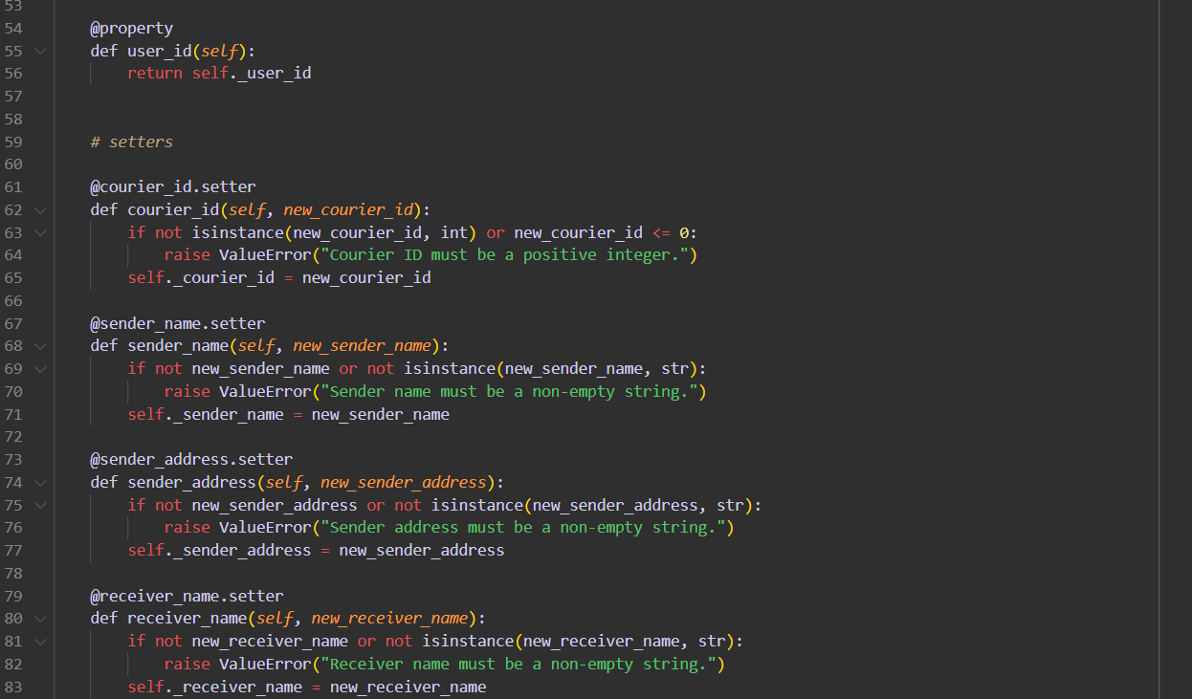

**3. Employee Class:**

**Variables employeeID , employeeName , email , contactNumber , role String, salary**

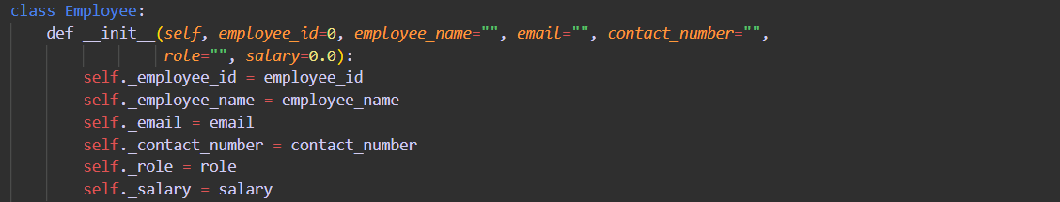

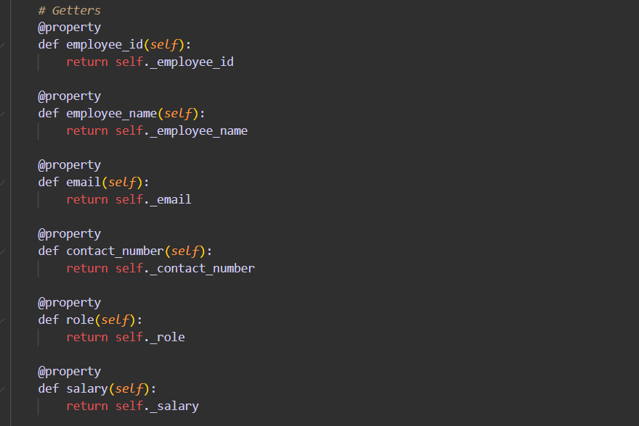

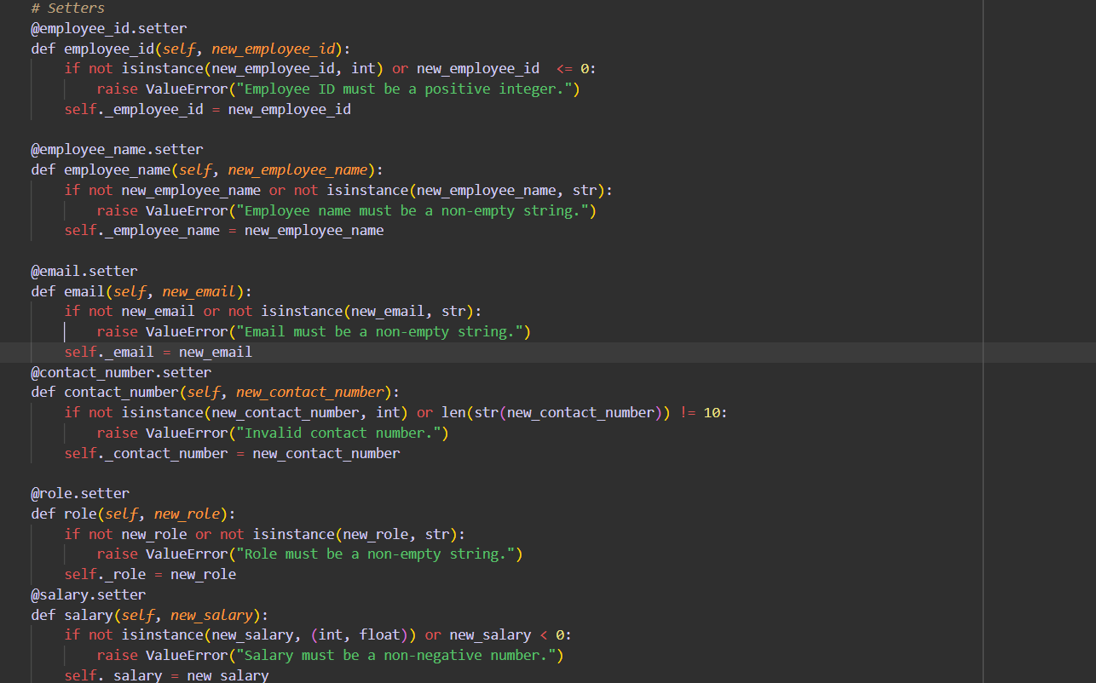

**4. Location Class**

**Variables LocationID , LocationName , Address**

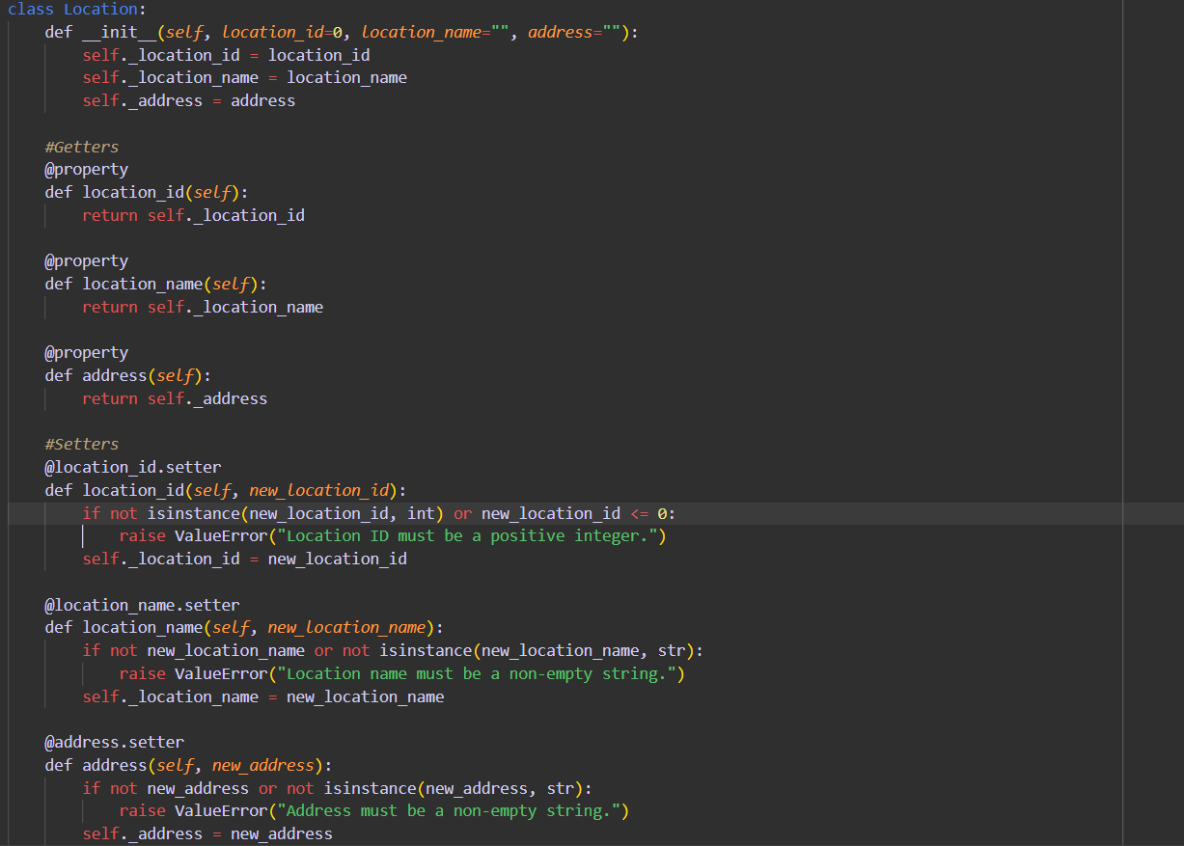

**5. CourierCompany Class**

**Variables companyName , courierDetails -collection of Courier Objects, employeeDetailscollection of Employee Objects, locationDetails - collection of Location Objects.**

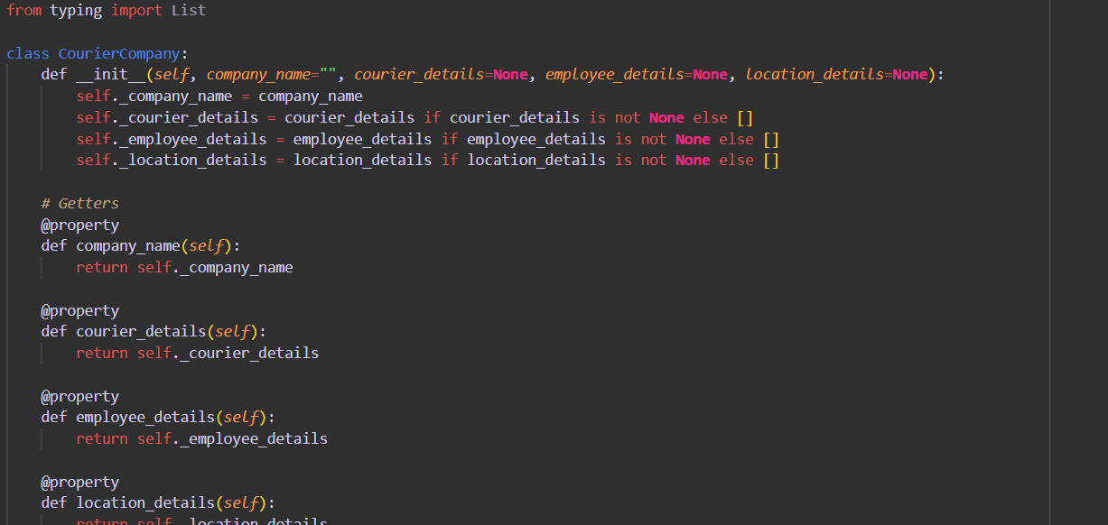

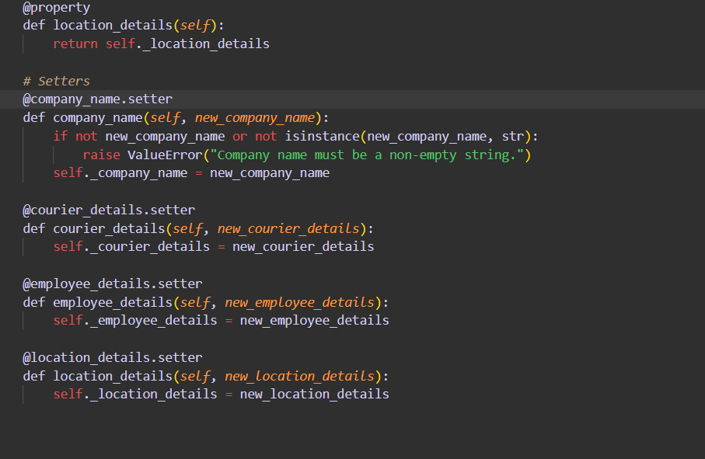

**6. Payment Class:**

**Variables PaymentID long, CourierID long, Amount double, PaymentDate Date**

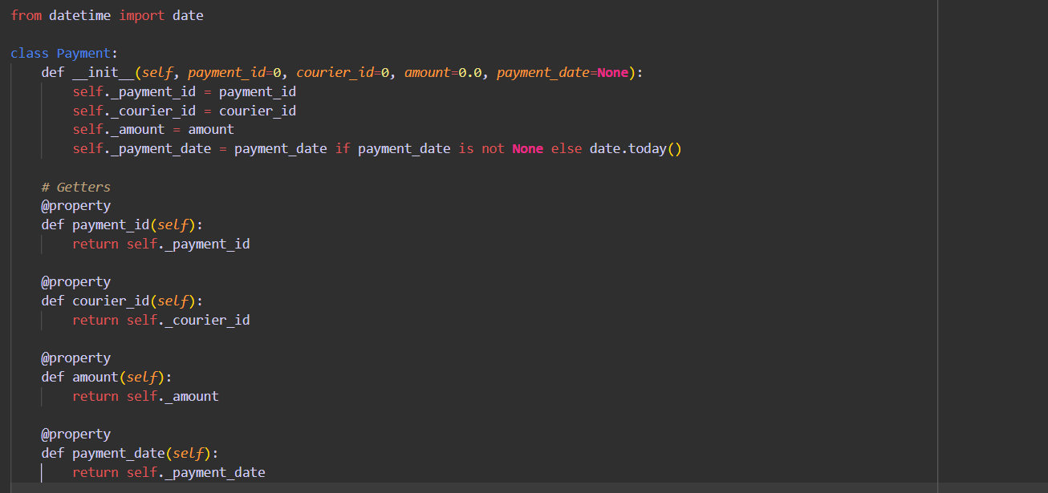

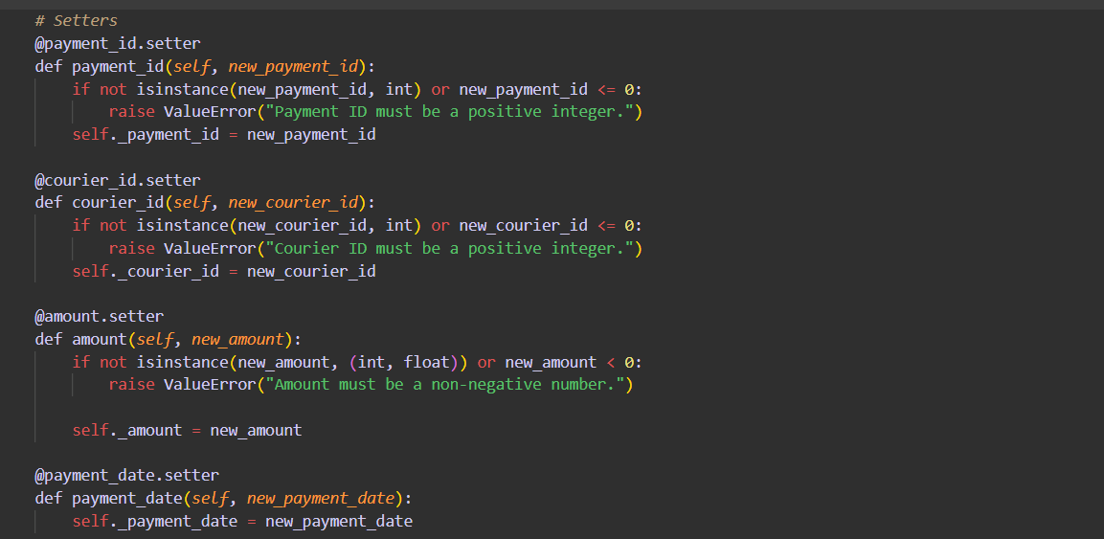

**Task 6(Abstract methods)**

**ICourierUserService**

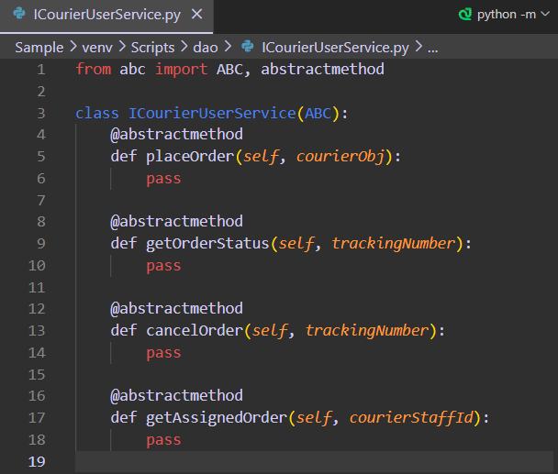

**ICOurierAdminServices**

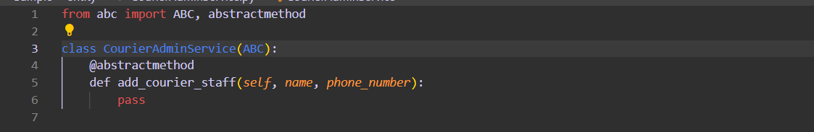

**Task 7 Exception Handling**

**1.TrackingNumberNotFoundException**

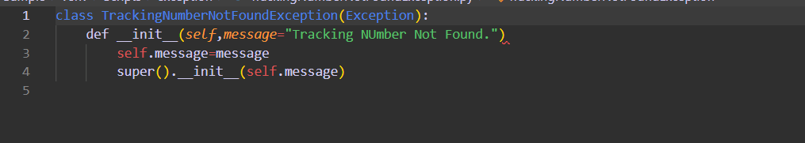

**2.InvalidEmployeeIdException**

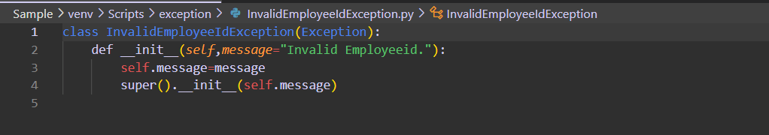

**Task 8 Courier User Service And Courier Admin Service Implementations.**

**CourierUserService**

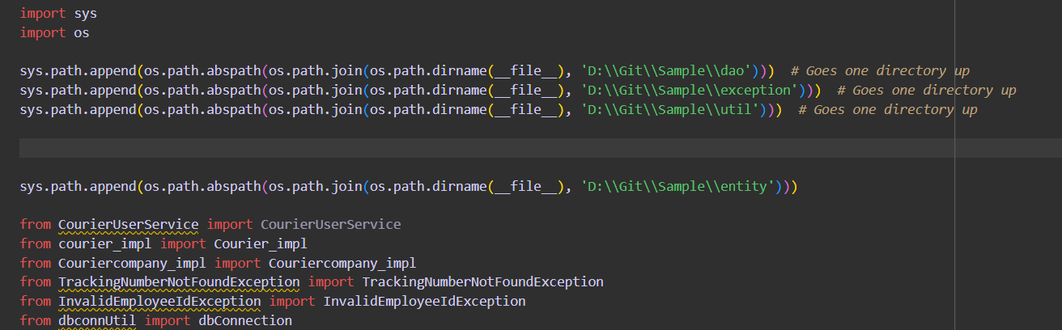

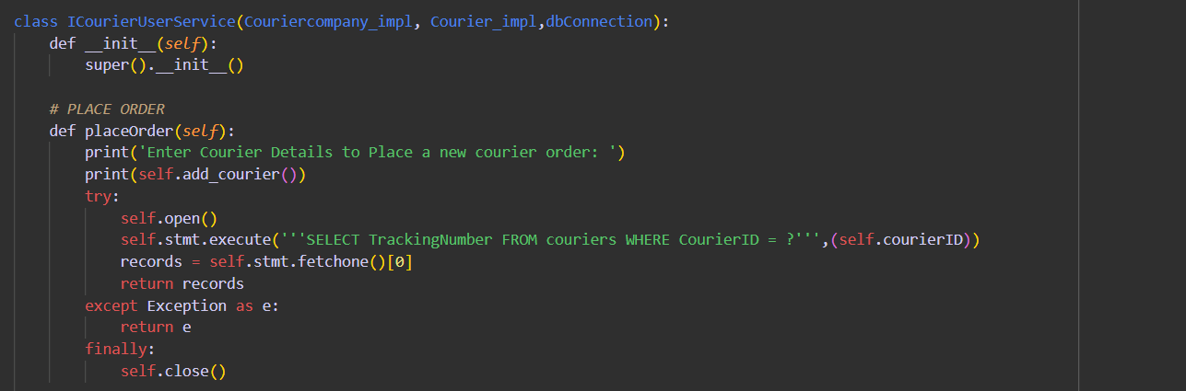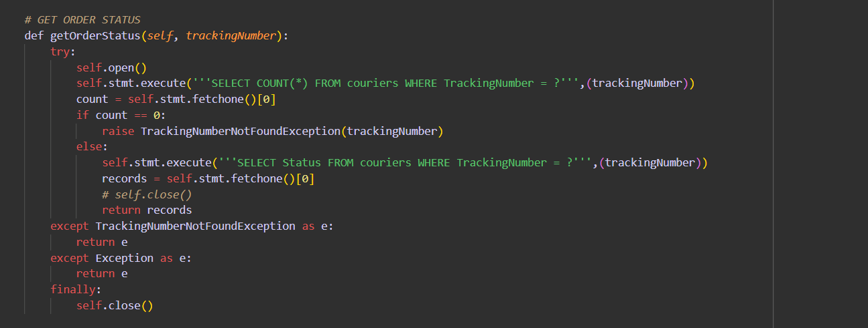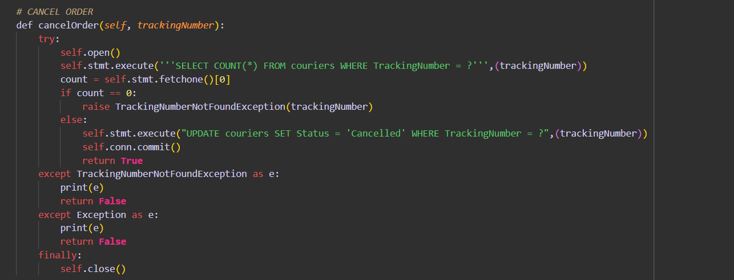

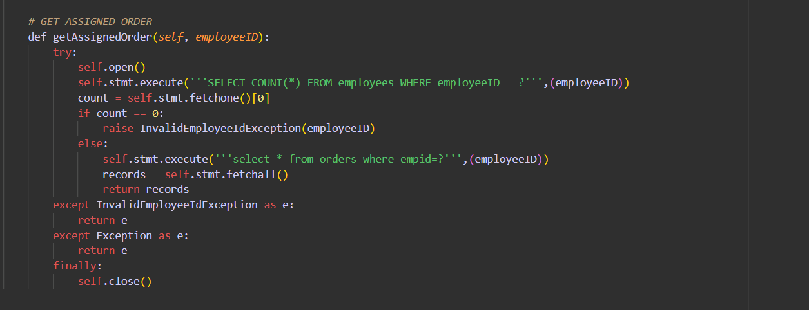

**8.3CourierAdminService**

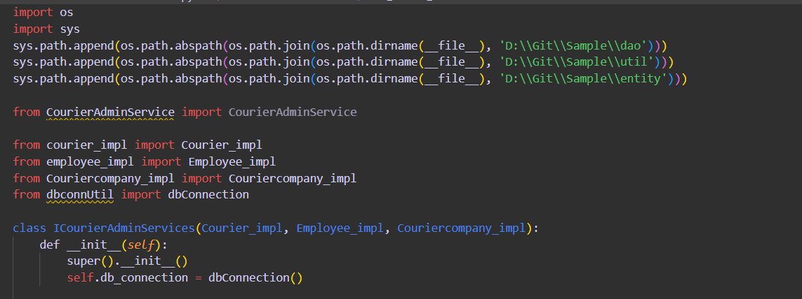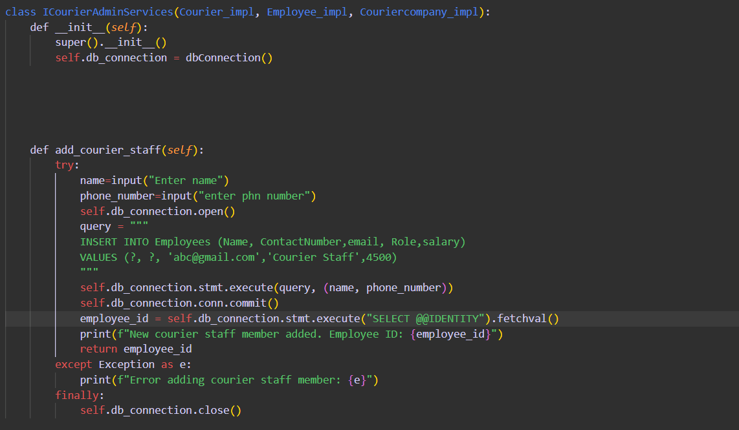

**Task 9**

**Task 9.1. DataBase Interaction**

**DBProperty: Fetching all details for establishing Database Connection**

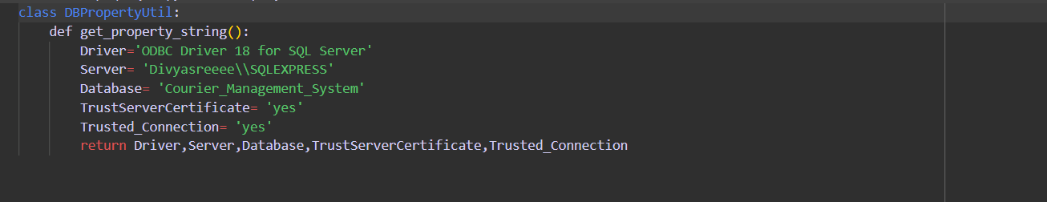

**DBconnection: Establishing connection through connection string**

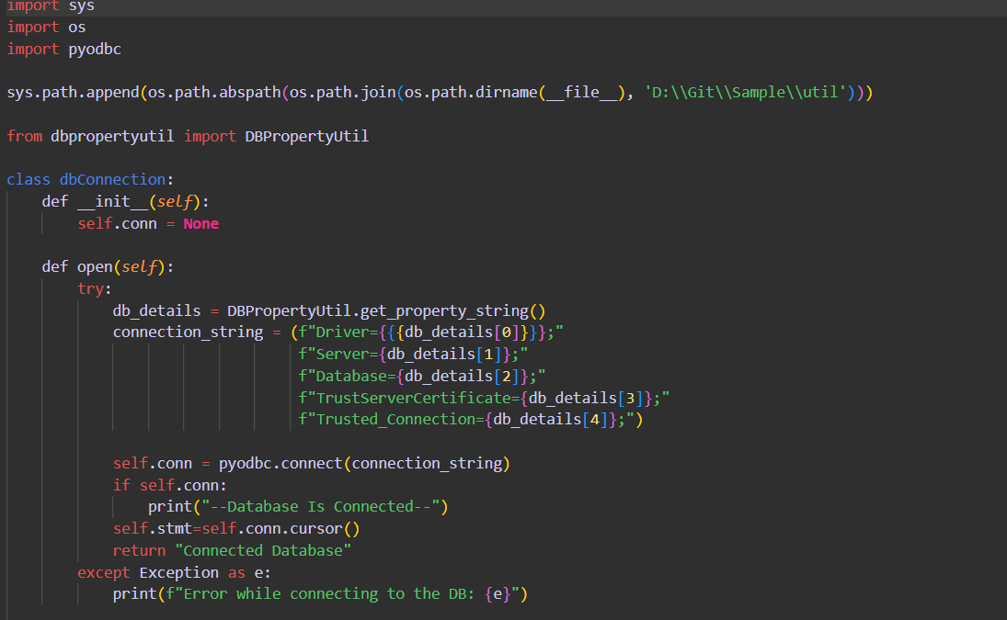 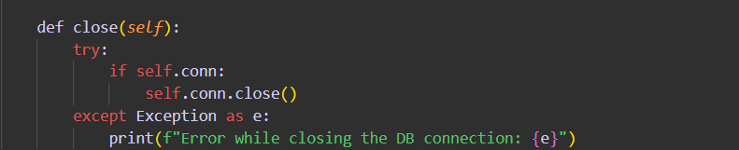

**Task 9.3. The classes and functions to select,add,update,delete are specified below**

**Function Implementations is dao folder**

**1.User_impl**

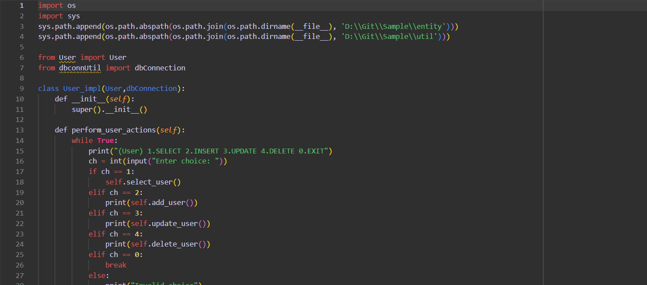 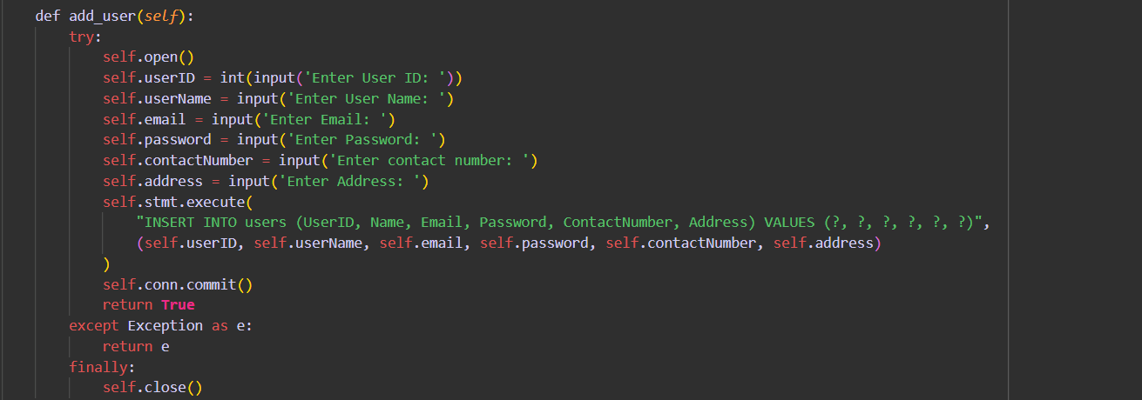 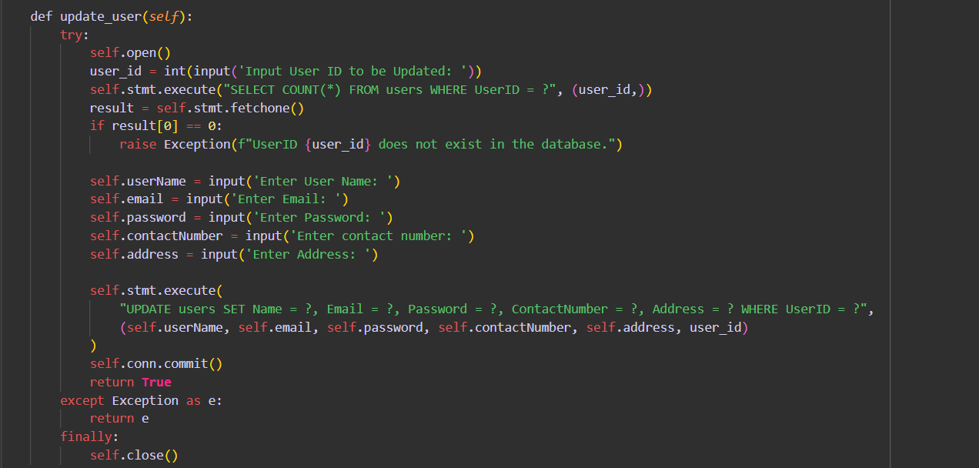

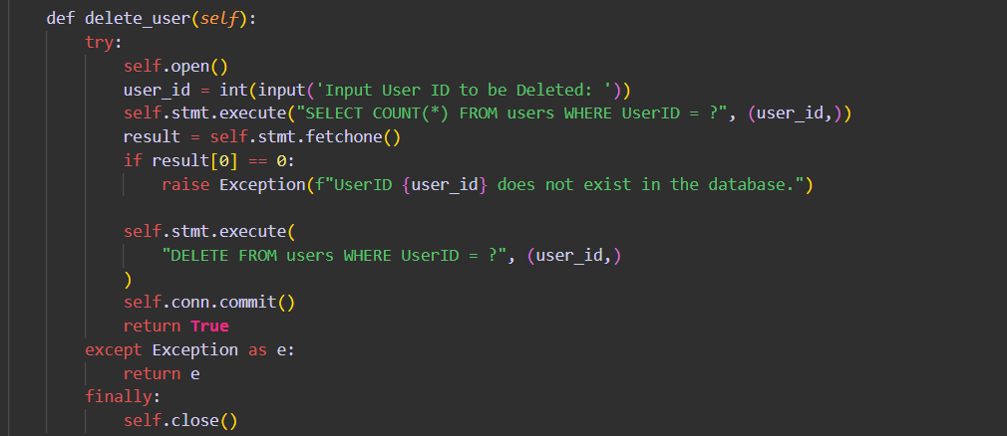 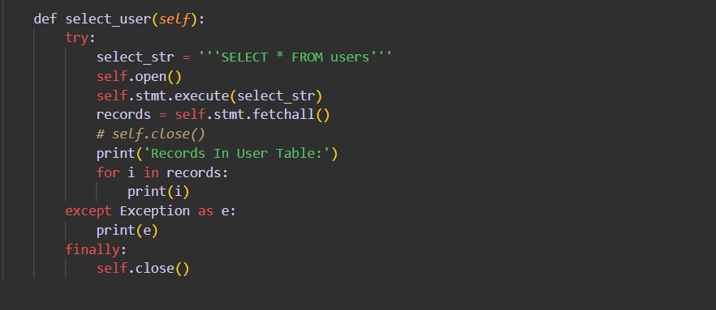

1. **Courier_impl**

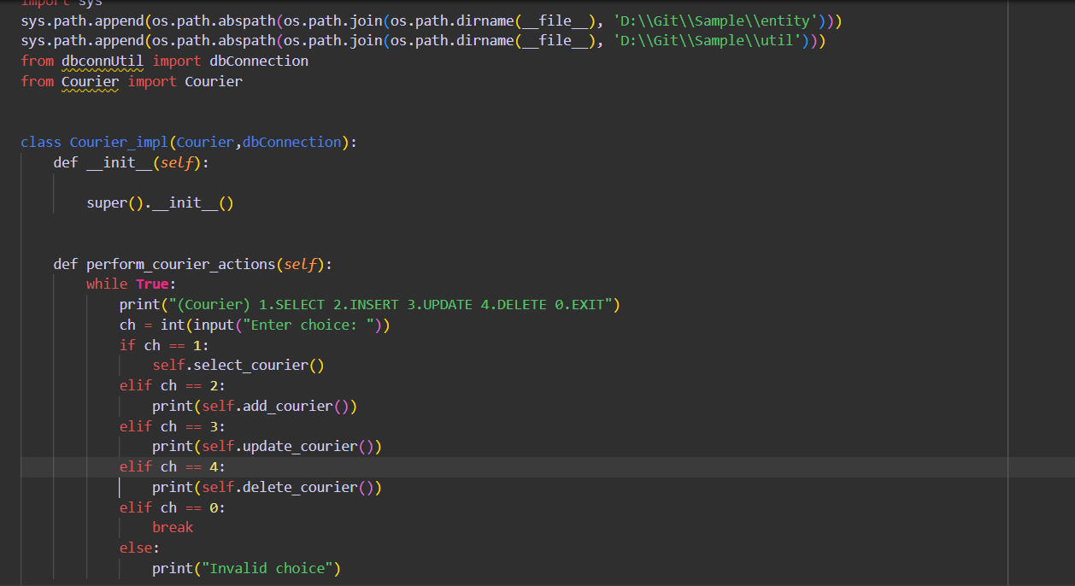

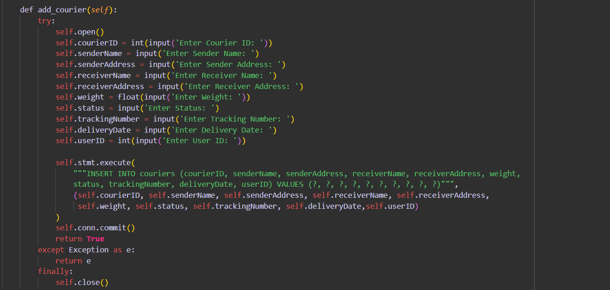 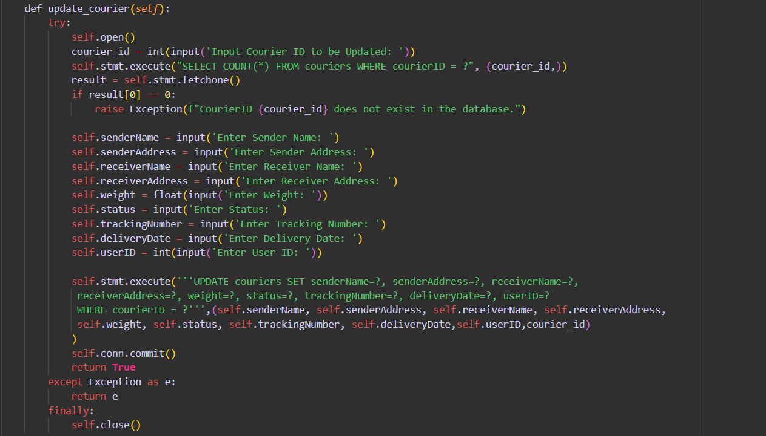 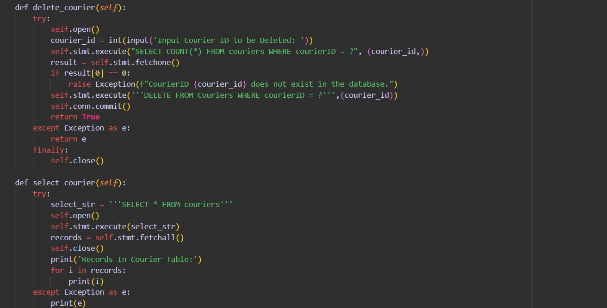

3.Location_impl

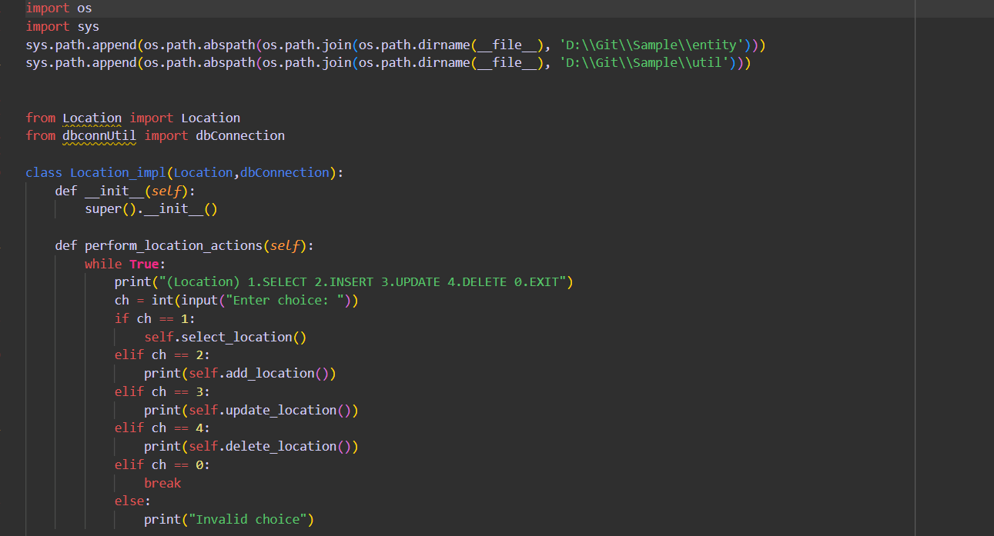 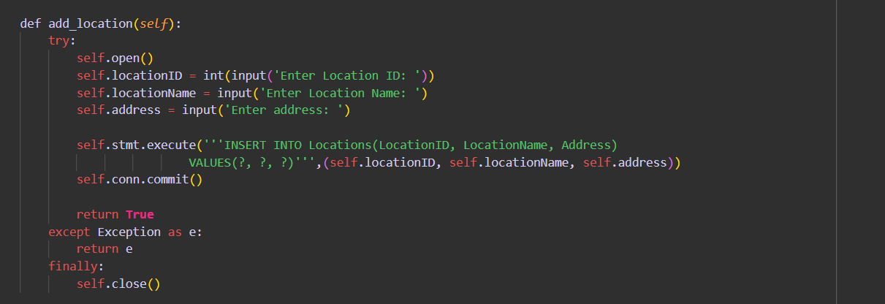

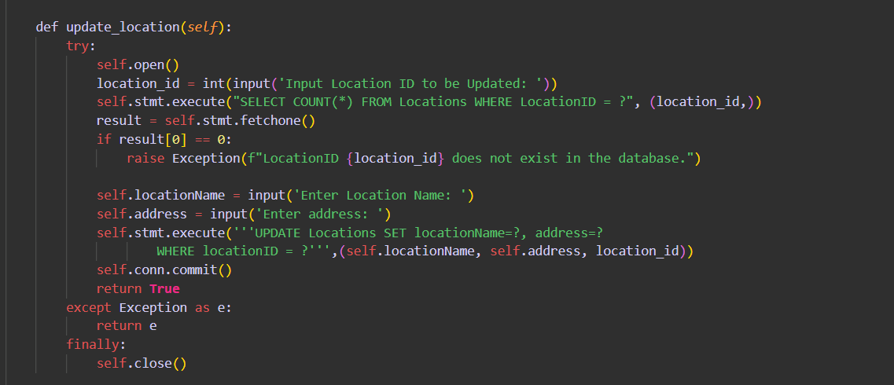 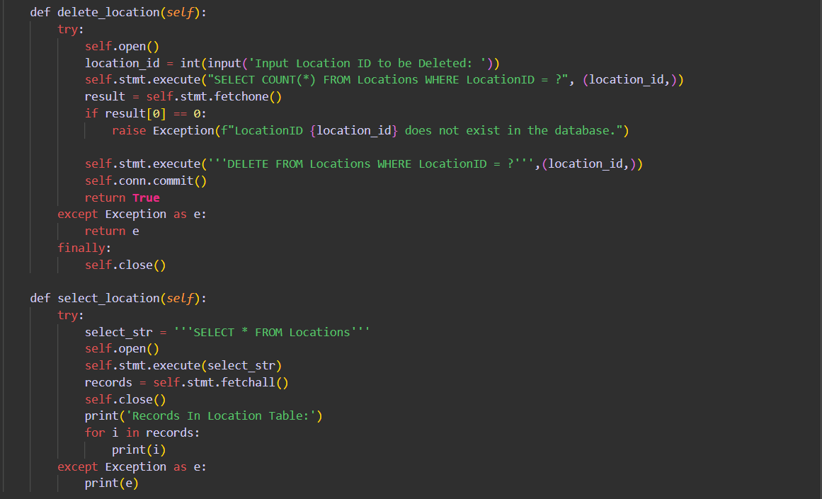

4.Payment_impl

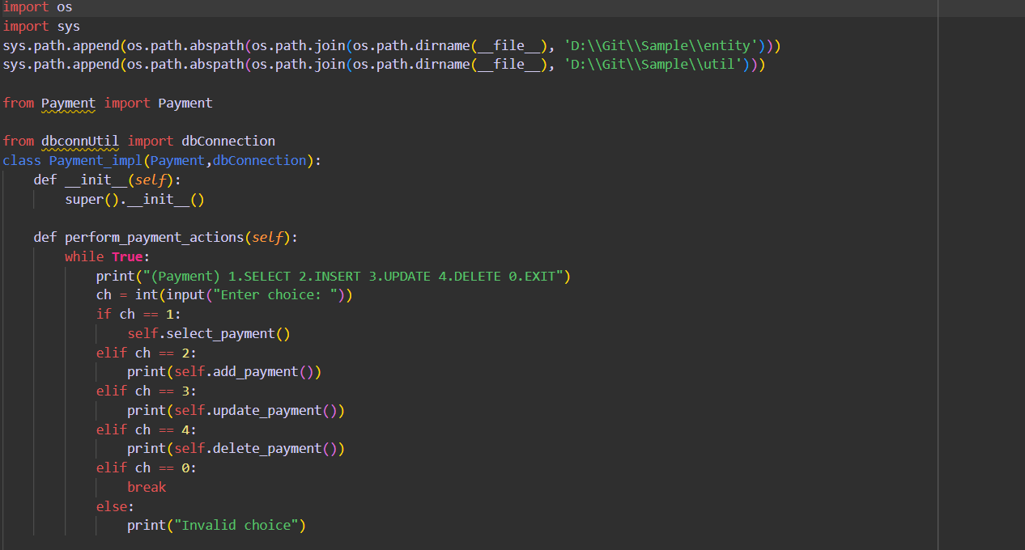 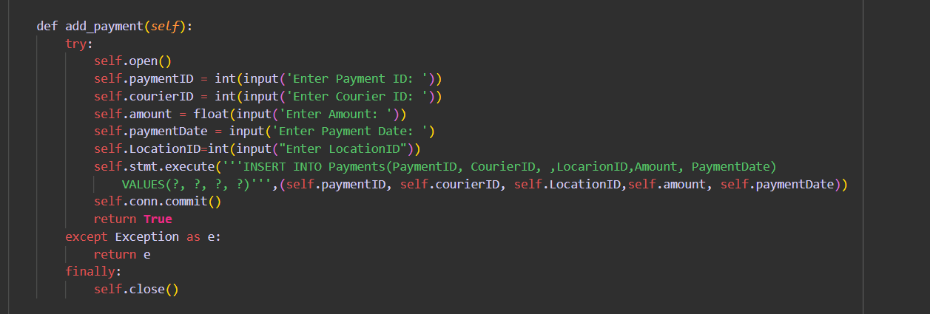 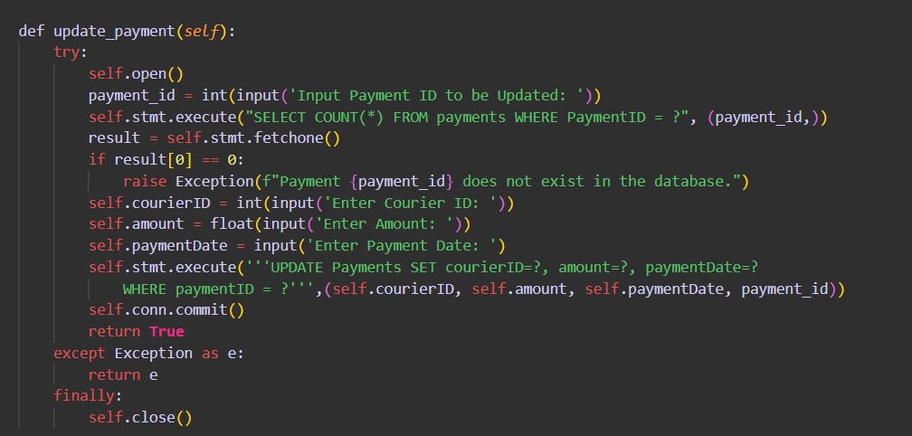

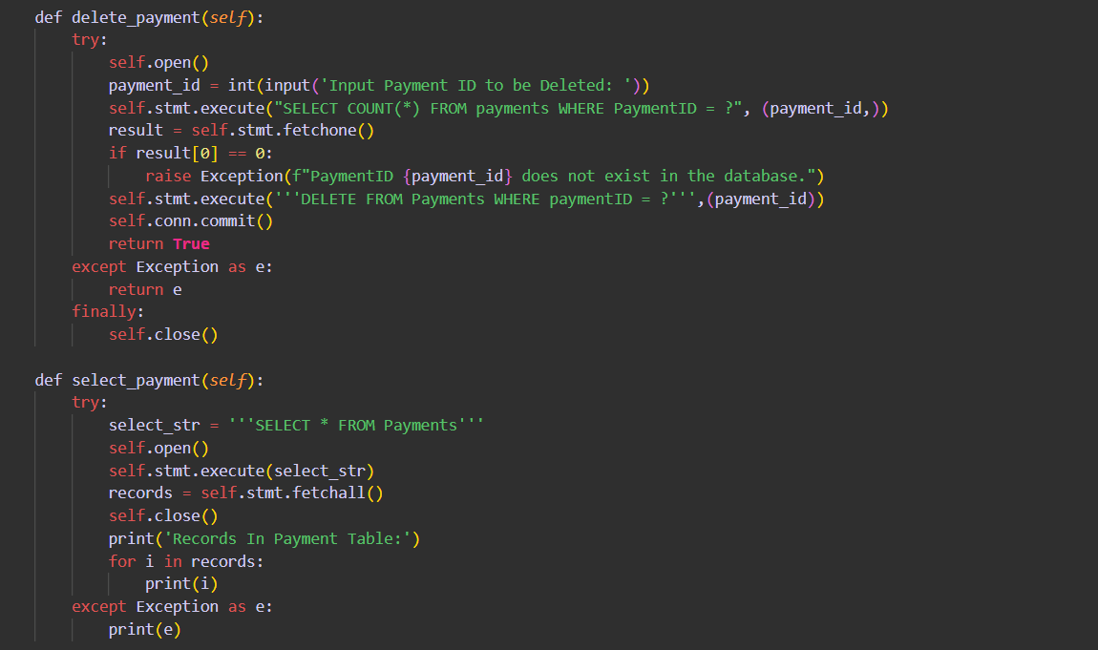

**5.employee_impl**

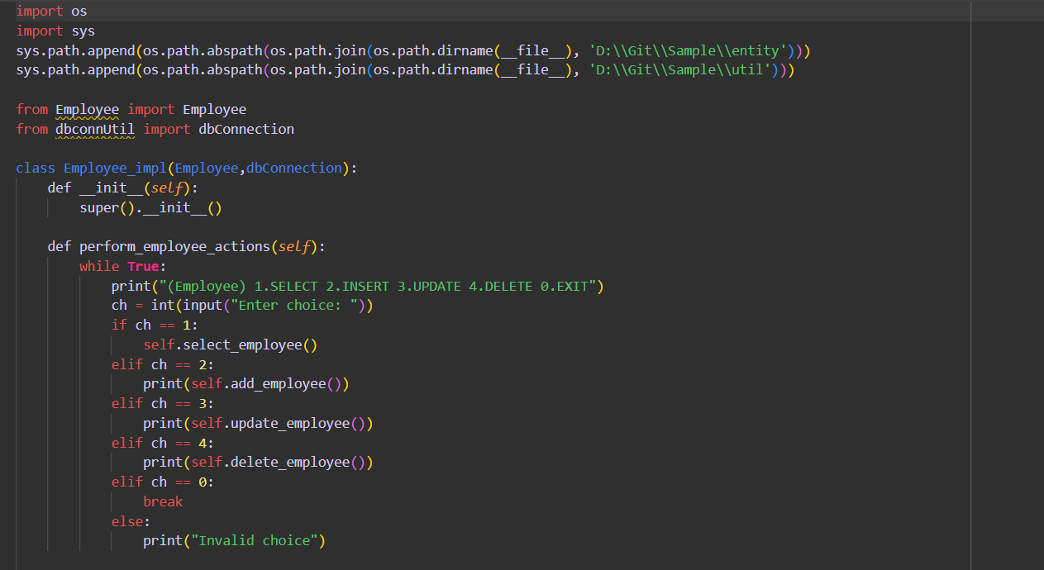

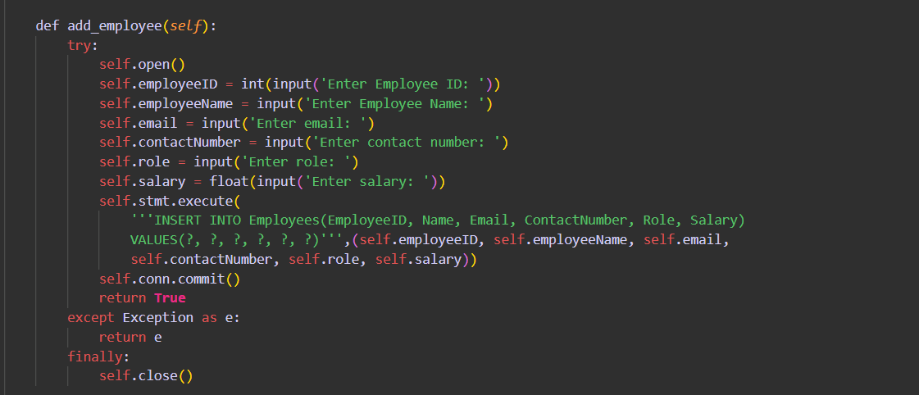

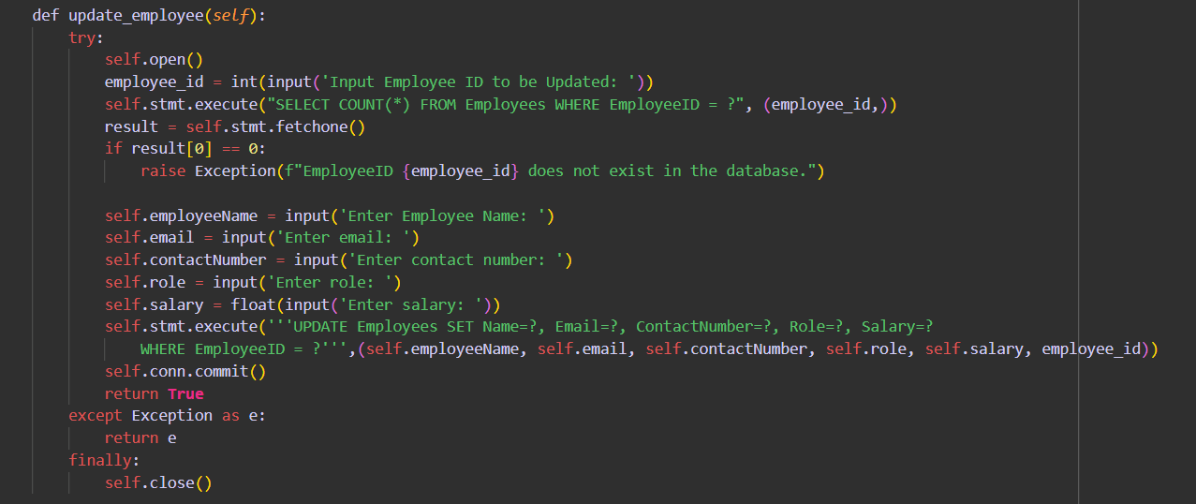 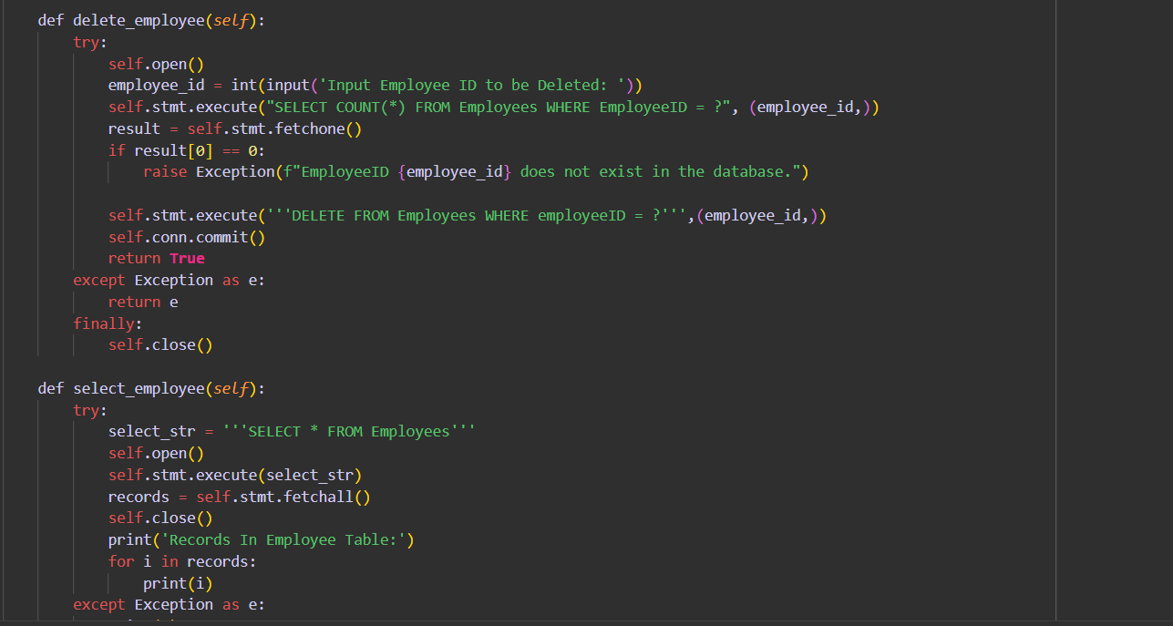

6.Couriercompany_impl

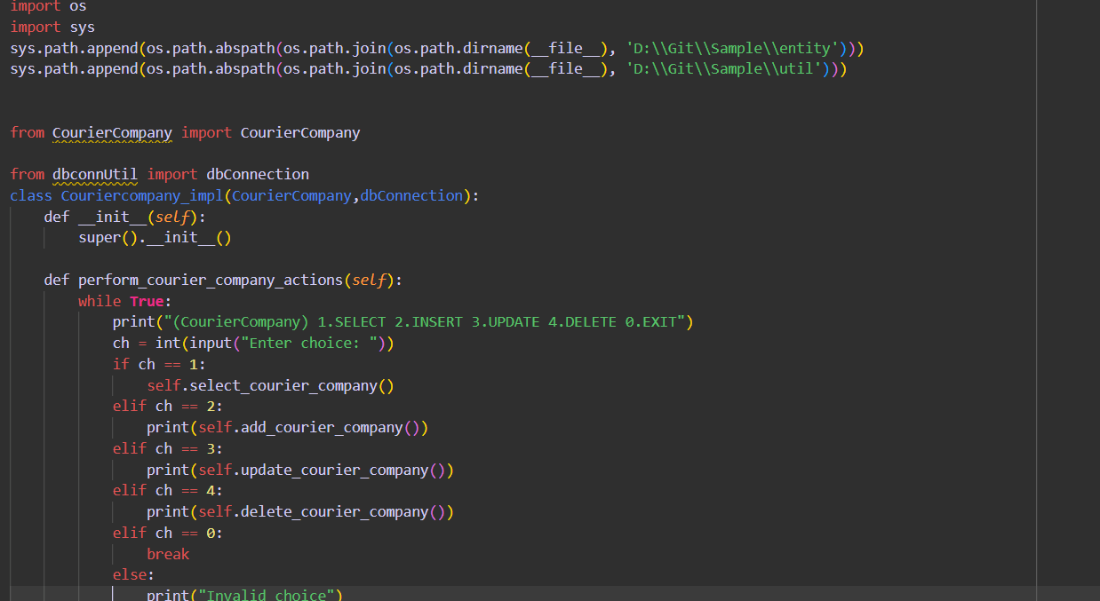 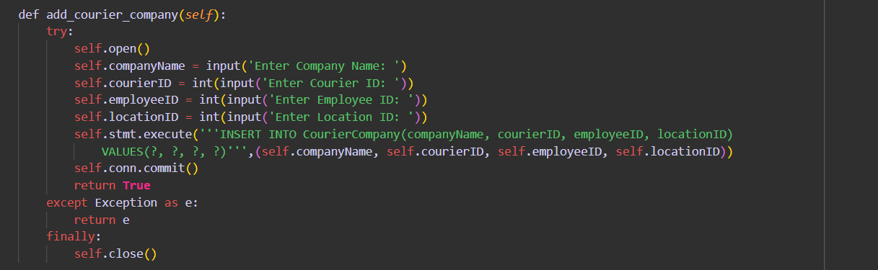 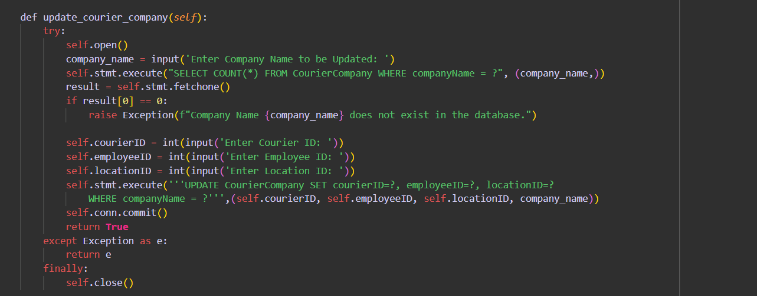

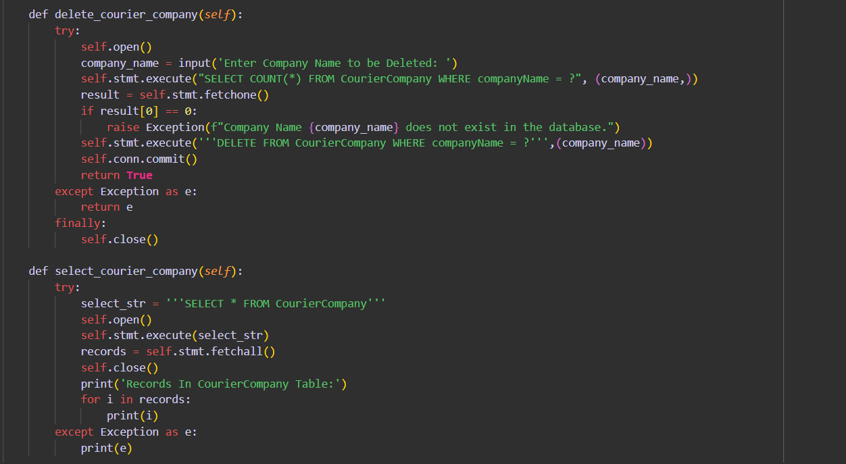 

**9.4.Generate revenue reports, generate shipment reports,get delivery status**

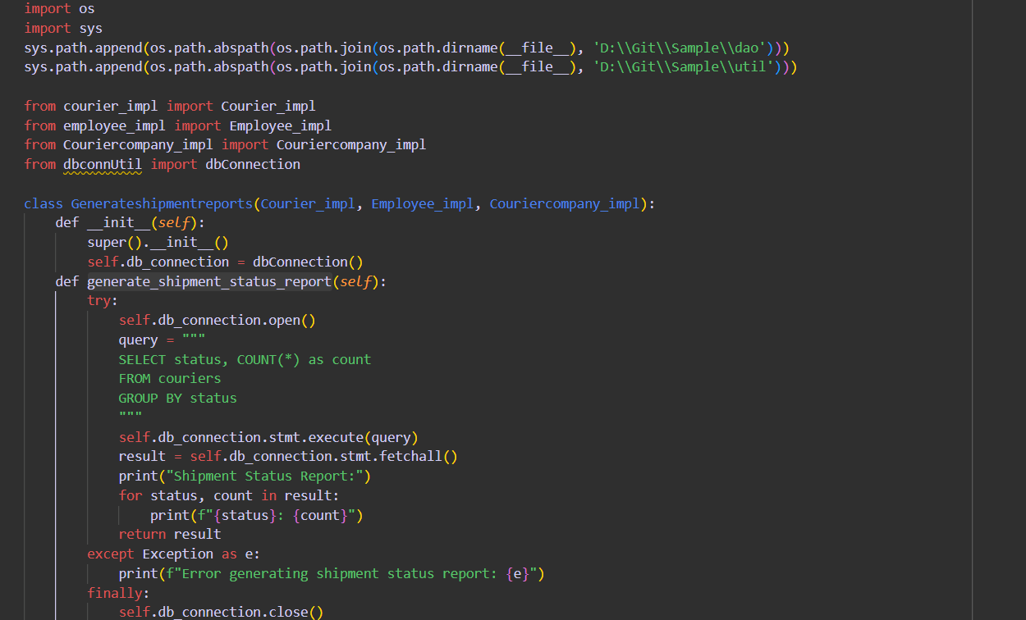

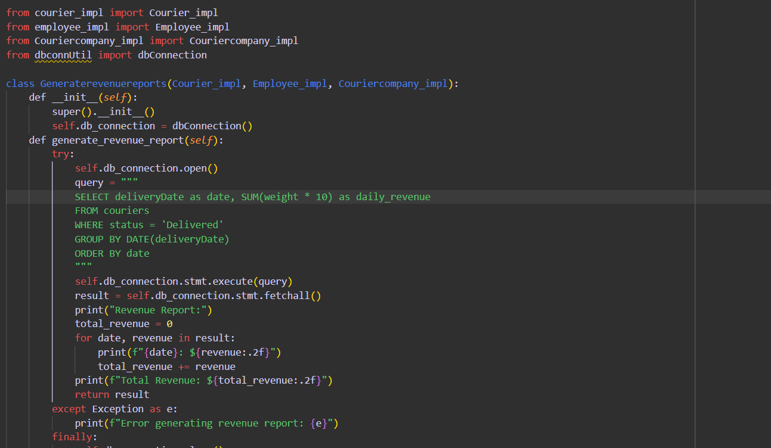

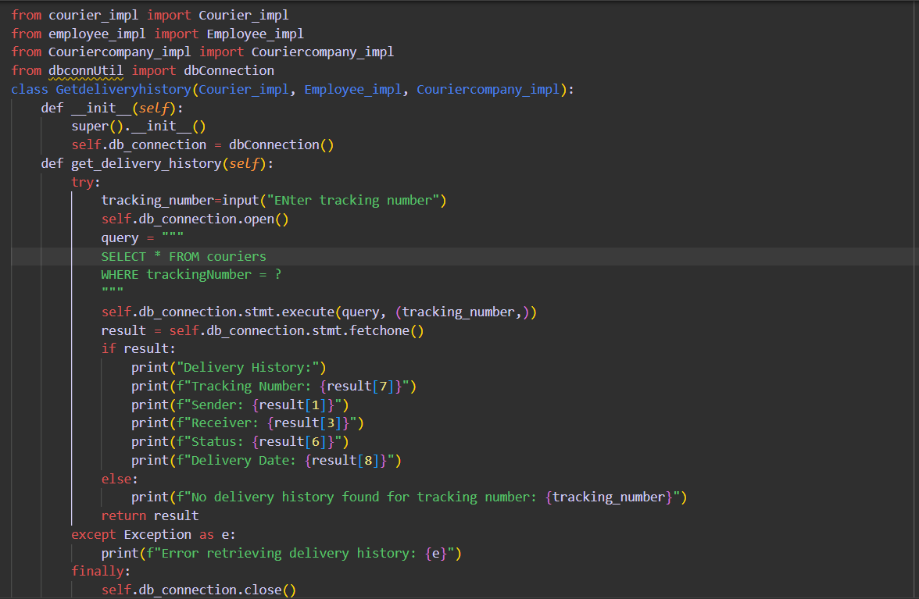

**Main function.**

**Importing necessary files from dao,exceptions,entity,util**

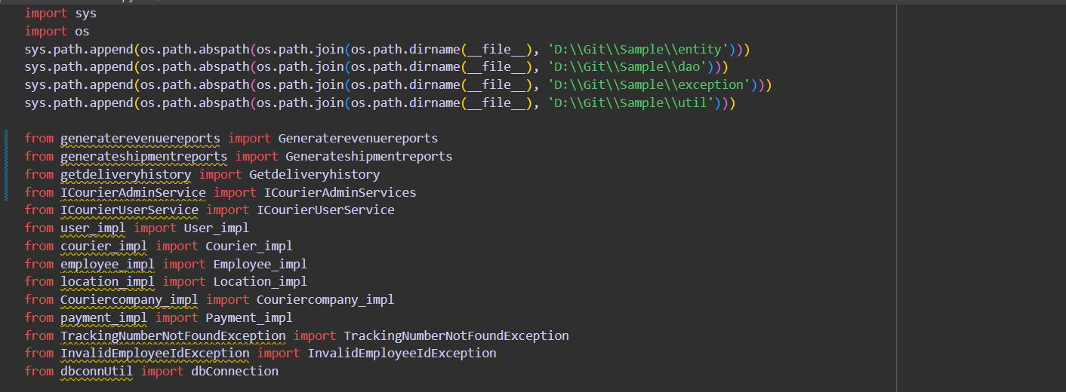

**DataBase Connection and object initializations**

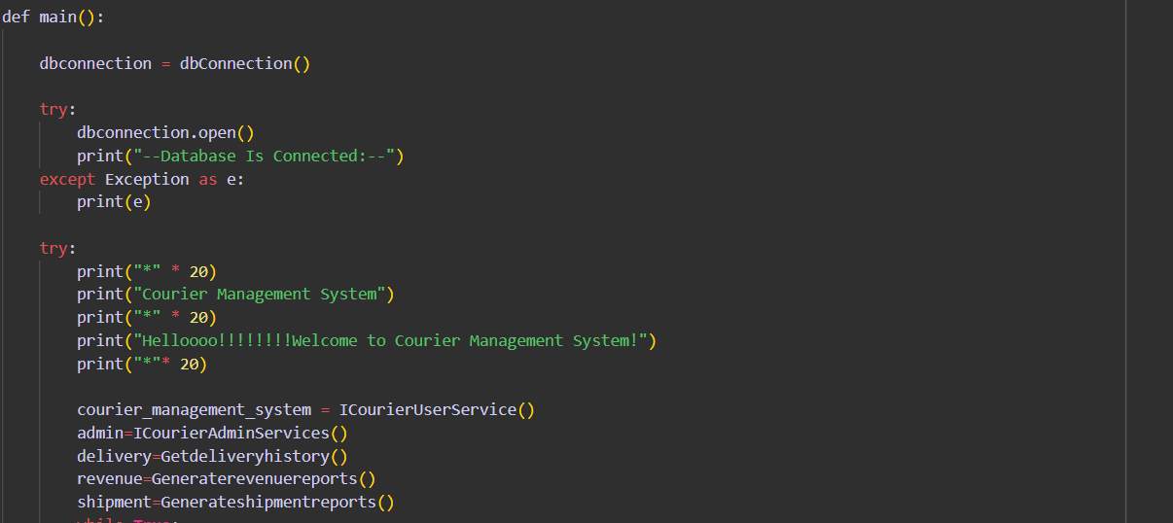

**Allowing Users to choose the relevant option**

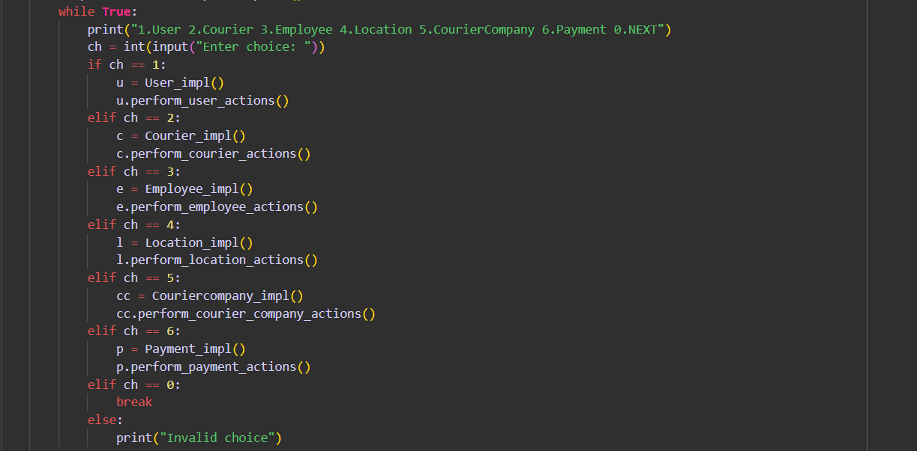

**Invoking methods to perform actions related to Courier User Service (Place Order,GetOrderStatus,cancelOrder,getassignedorder)**

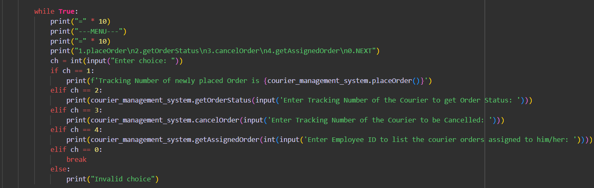

**Perform actions like getdeliverystatus,generate shipment and revenue report and add courierStaff**

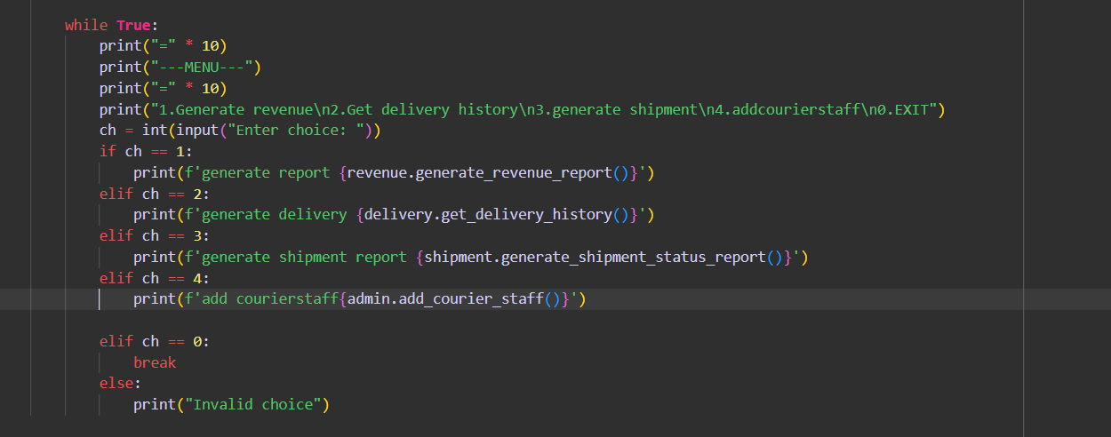

**Using exceptions and closing the db connection**

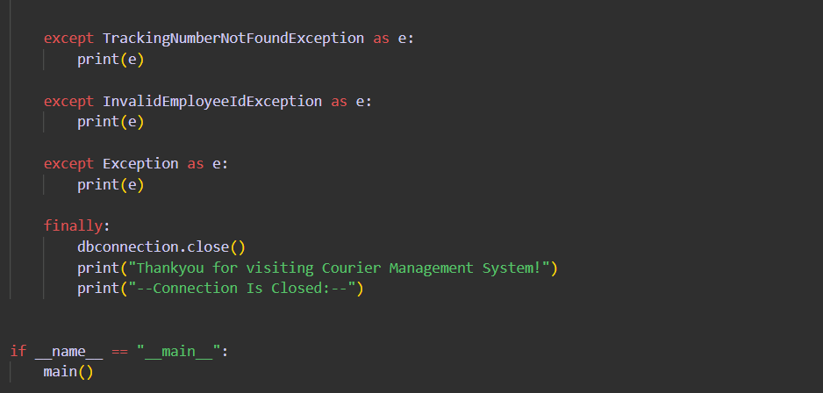

**Code Outputs**

**1.Performing add,select,delete,update in users/customers**

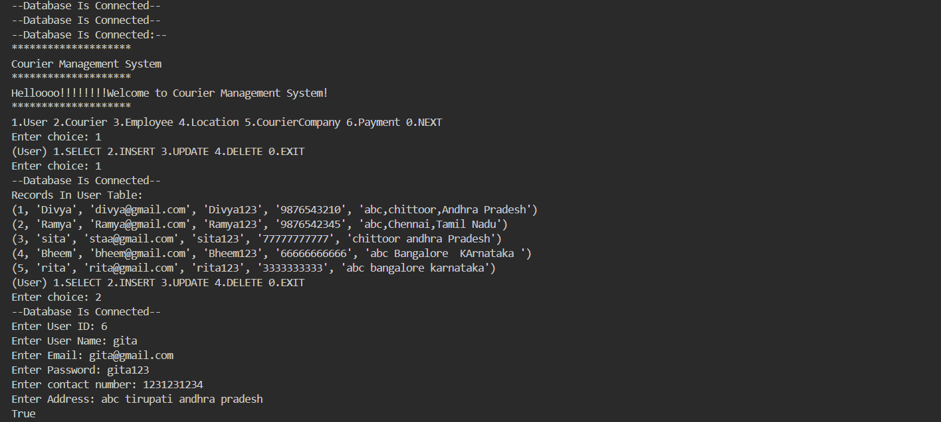

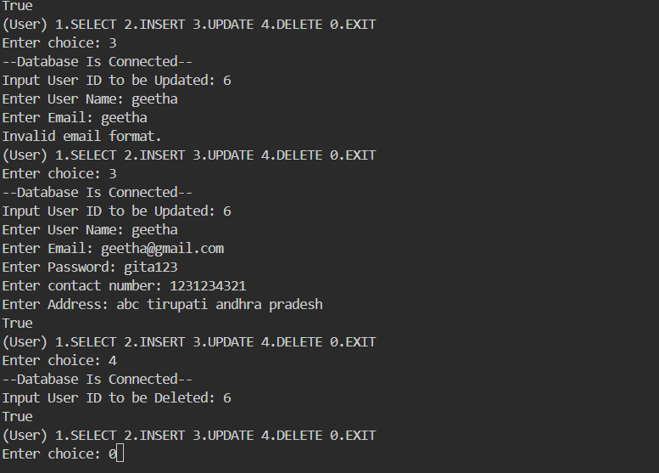

**2.Performing add,select,delete,update in couriers**

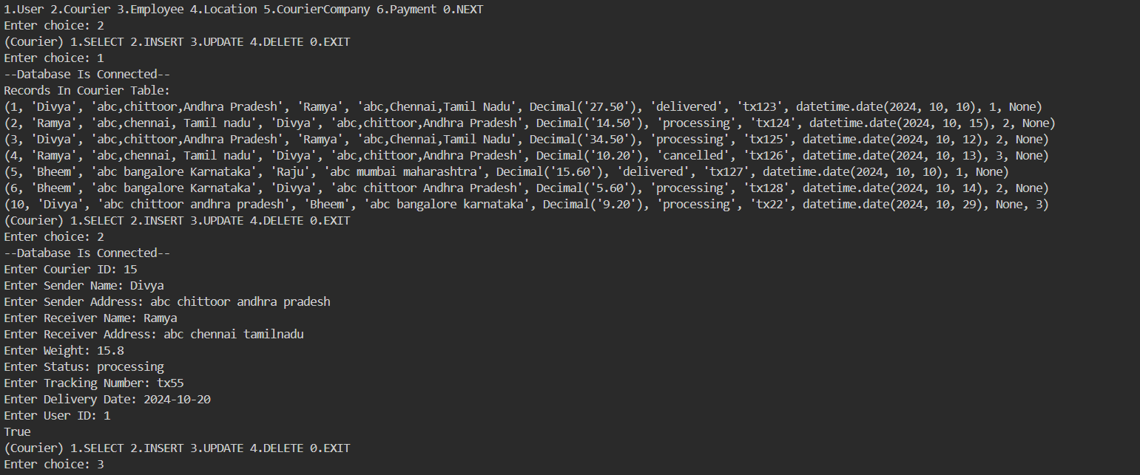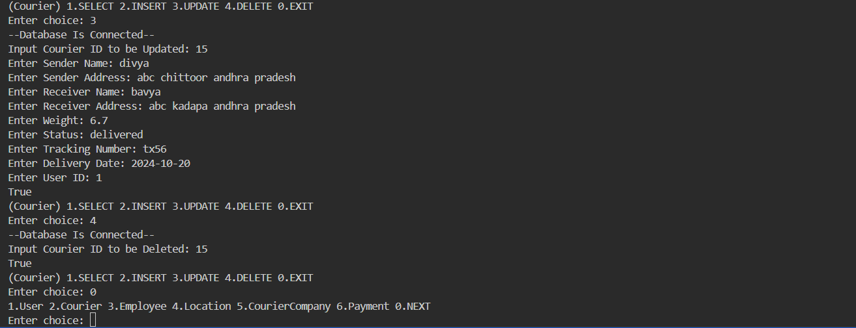

**3.Performing add ,select,delete,update in employee**

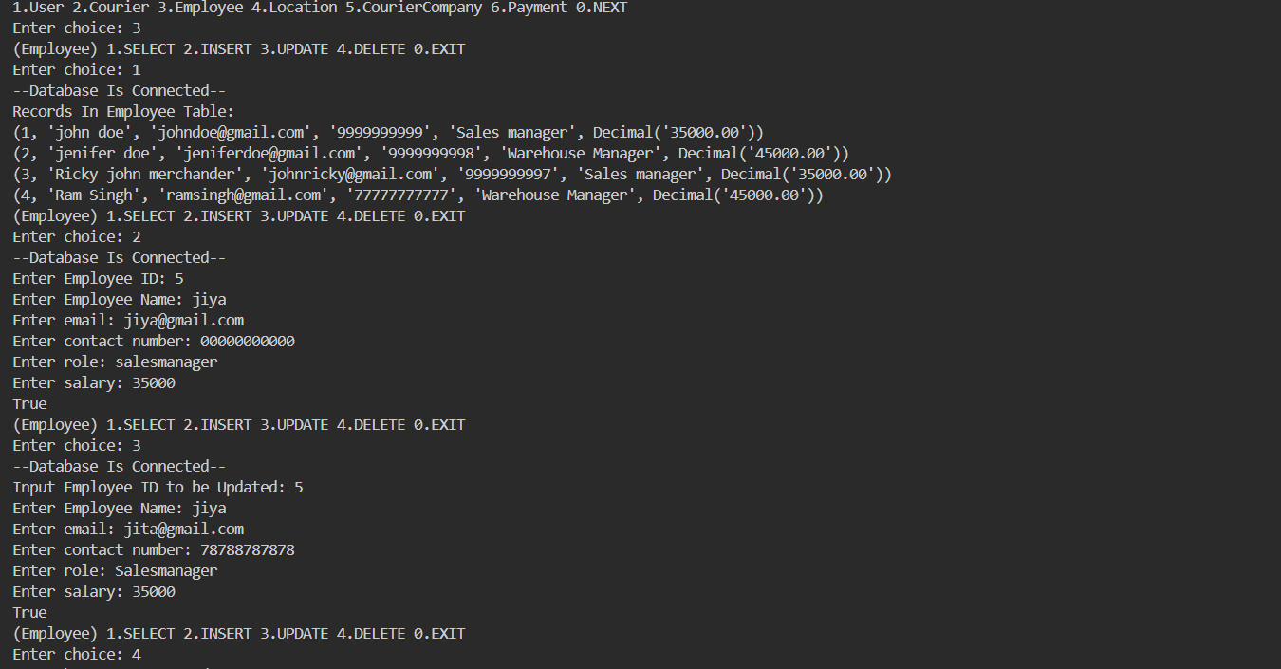

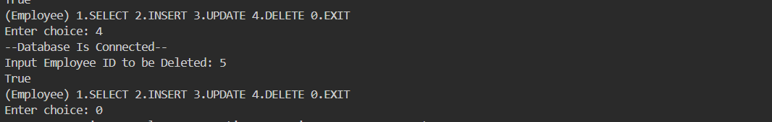

**4.Performing add ,select,delete,update in Location**

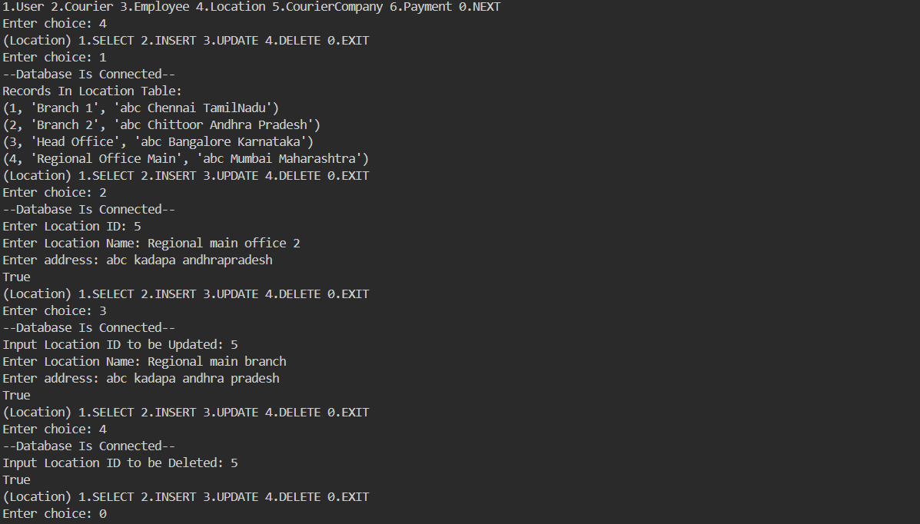

**4.Performing add ,select,delete,update in Courier Company and Payments**

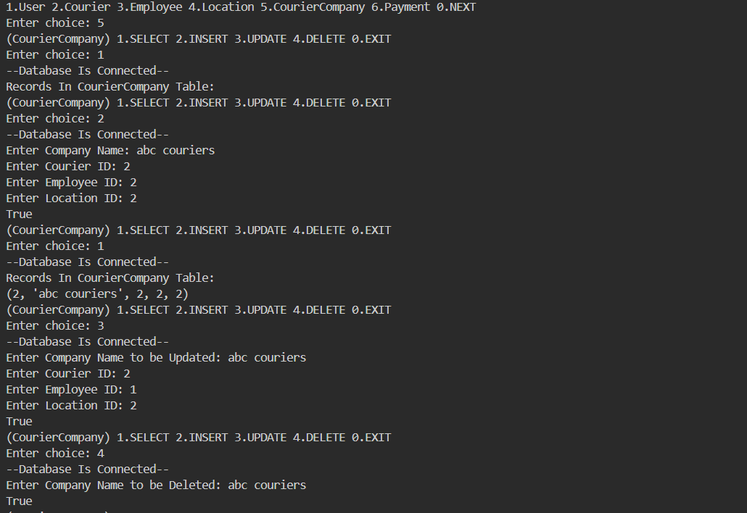

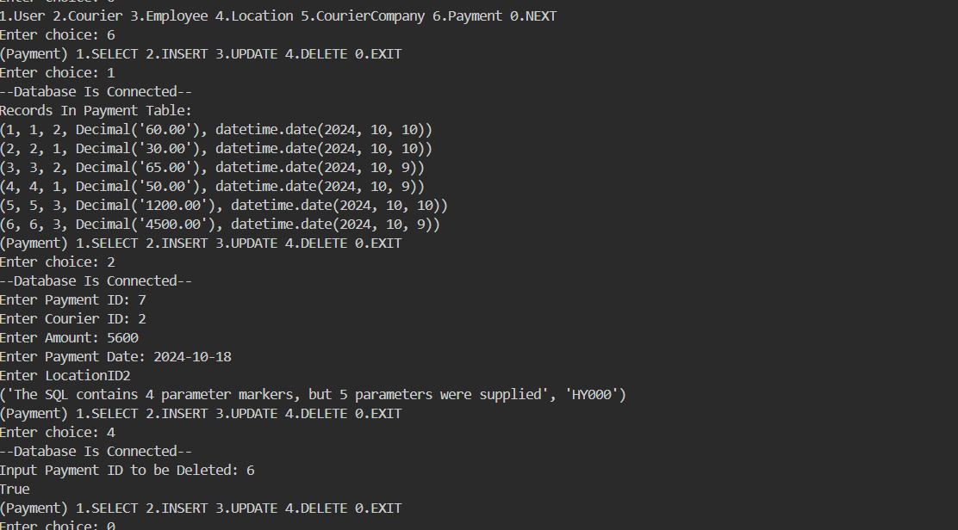

**5.PlaceOrder**

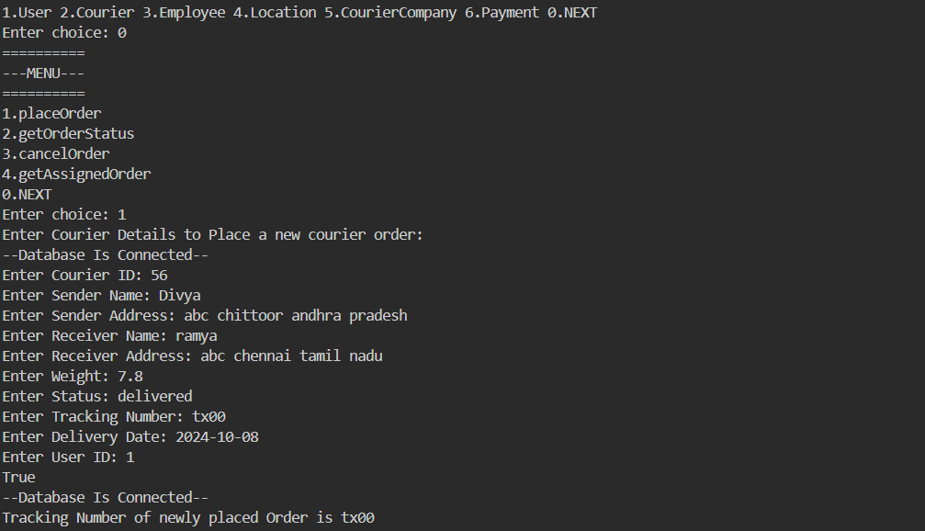

**6.getorderstatus**

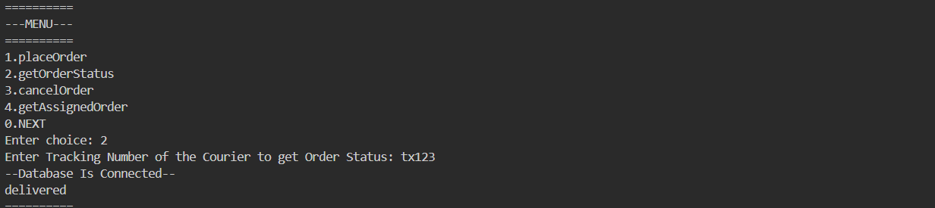

**7.cancelorder**

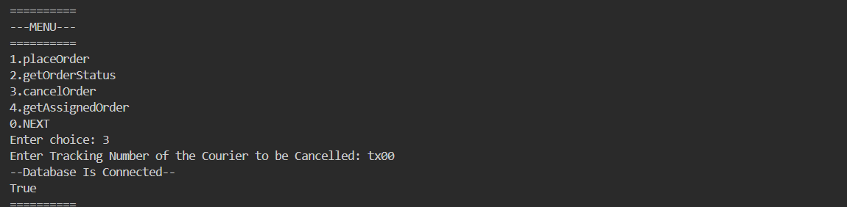

**8.** **get assigned order**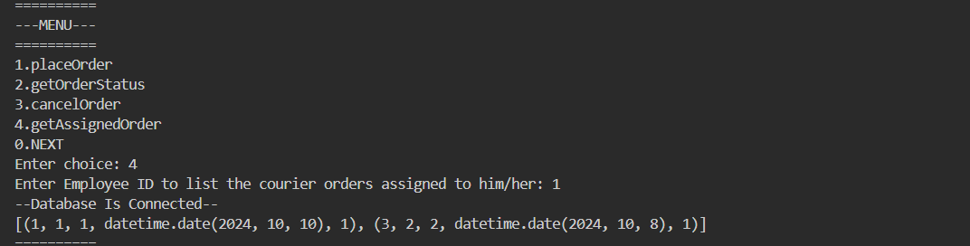

**9.add courier staff**

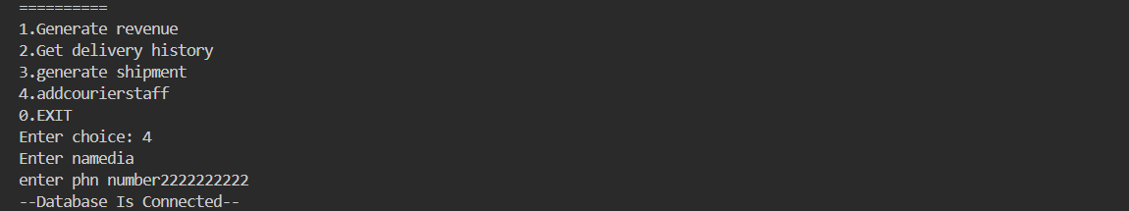

**10.Generate Revenue report**

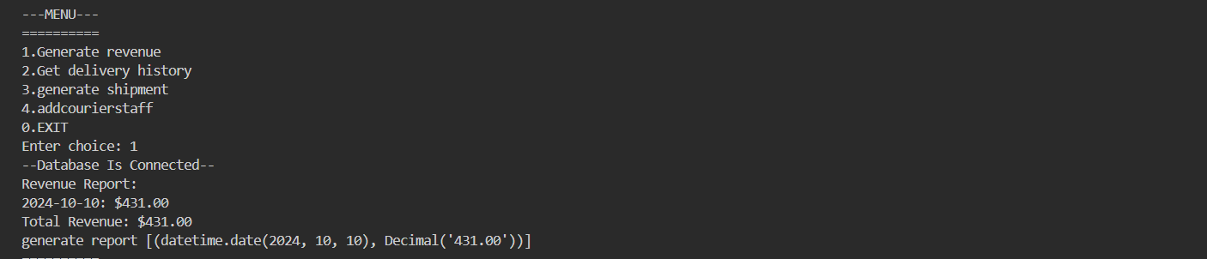

**11.Get delivery status and details**

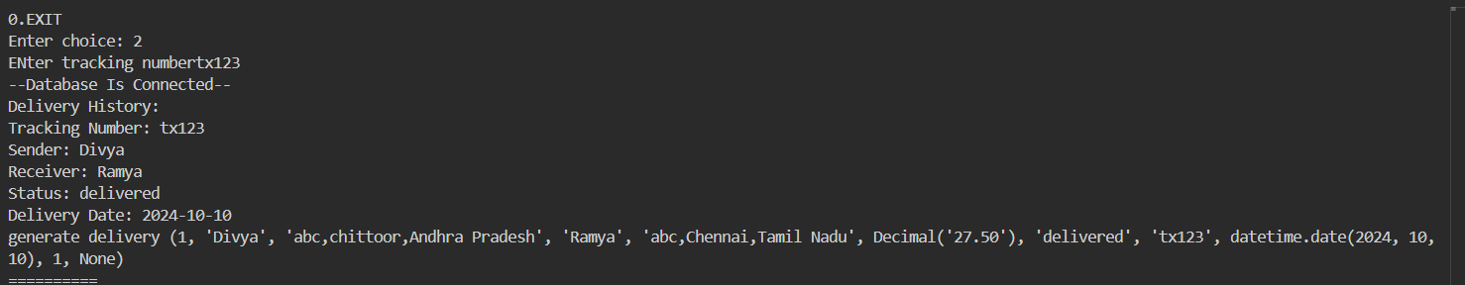

**12.Generate shipmentreport**

